

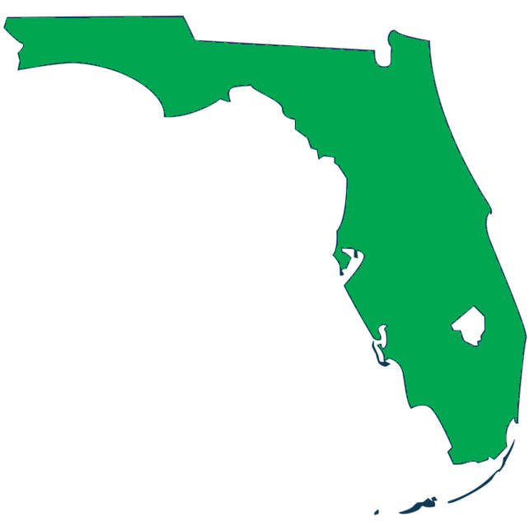

2025
Economic Security Report
Released December 2025
Outcomes for Graduates of Florida Public Postsecondary Institutions

Prepared by:
Florida Department of Commerce,
Bureau of Workforce Statistics and Economic Research (WSER)

About This Report
The Florida Economic Security Report, per section 445.07, Florida Statues, provides information on employment and earnings outcomes for individuals who graduated from Florida’s postsecondary educational institutions. Results presented in this report show the variation in earnings, employment, election to continue education and proportion of public assistance recipients for graduates of Florida’s three public educational systems. The average federal debt acquired by all students in a public postsecondary education institution (not just graduates) in academic year 2021-22 is also reported. The results show what types of postsecondary credentials students earn and what they study.

Information in this report comes from four main data sources:
- Florida Department of Education Florida Education and Training Placement Information Program (FETPIP)
- Florida Department of Education Office of Student Financial Assistance
- Florida Department of Commerce Employment Projections
- U.S. Department of Labor State Wage Interchange System (SWIS)

The data detailed in this report reflect outcomes for 1,118,829 graduates in their first year after graduation for a five-year period from academic years 2017-18 through 2021-22 and for 212,329 graduates in their fifth year after graduation, 2017-18. All earnings and employment data are provided through the Florida Department of Education (DOE). Although the data represent employment and earning outcomes, the data do not include information about the occupations of graduates or whether they are employed in their field of study.
More information on the methods contained in this report can be found in the Appendix section at the end of the report.

Florida’s public postsecondary education system consists of 88 institutions within the following three systems: District Technical Centers, the Florida College System and the State University System of Florida.

District Technical Centers (DTCs)
DTCs are a system of 48 centers that offer certifications in a variety of career and technical education program areas. Career and adult education programs are designed to meet the needs of students and industries. DTCs represent a significant collaboration and partnership across both private and public sectors throughout Florida with the goal of improving Florida's workforce.

Learn more about Career and Adult Education at the Florida Department of Education: Career & Adult Education (fldoe.org)

Florida College System (FCS)
The FCS is the primary access point to higher education for Floridians, accounting for nearly half of all graduates in the five-year period. The FCS consists of 28 public community colleges and state colleges that offer a mix of two-year and four-year programs. It is designed to respond quickly and efficiently to meet the demand of employers by aligning certificate and degree programs with regional workforce needs.

Learn more about the Florida College System at the Florida Department of Education: Florida College System (fldoe.org)

State University System of Florida (SUS)
Ranked #1 in Higher Education by U.S. News and World Report for nine consecutive years, the 12 public universities comprising the SUS provide rigorous, high-quality education in more than 1,800 programs at the graduate, postgraduate and professional levels. The statewide system, created in 2002, boasts more than 430,000 students and more than 60,000 faculty and staff with a budget greater than $17.3 billion in 2024-25.

Learn more about SUS institutions at the SUS Board of Governors website: State University System (flbog.edu)

Contents
Page
About This Report ii
District Technical Centers (DTCs) iii
Florida College System (FCS) iii
State University System of Florida (SUS) iii
Executive Summary 3
Outcomes at a Glance 4
Experience 5
Progress 5
Student Debt 9
Public Assistance 9
Labor Market 9
Certificates, Diplomas and Apprenticeships 11
Certificate Outcomes 12
Applied Technology Diploma Outcomes 13
Apprenticeship Outcomes 13
What Students Study 14
Certificate, Diploma and Apprenticeship Students Continuing Their Education 20
Associate Degrees 21
Associate in Arts Degree Outcomes 22
Associate in Science Degree Outcomes 22
Associate in Applied Science Degree Outcomes 22
Advanced Technical Certificate Outcomes 22
What Students Study 23
Associate Degree Students Continuing Their Education 26
Bachelor’s Degrees 28
Bachelor’s Degree Outcomes 28
What Students Study 28
Bachelor’s Degree Students Continuing Their Education 30
Master’s and Specialist Degrees 32
What Students Study 32
Doctorate Degrees 35
Doctorate Degree (Law) Outcomes 36
Doctorate Degree (Medical) Outcomes 36
Doctorate Degree (Non-Medical) Outcomes 36
What Students Study 37
Student Loan Debt 38
Public Assistance 40
Labor Market Information: Which Jobs Are In Demand? 42
Industry Growth 42
Occupational Growth 46
Appendix 49
Graduate Cohort Classes 2017–18 Through 2021–22 49
Key Concepts 49
Definitions 50
Data Disclosure 52

Executive Summary
This report documents the variation in earnings, employment, election to continue their education and public assistance among graduates who have earned degrees or certificates from Florida’s public postsecondary education institutions. Results show that economic outcomes are primarily correlated with a student’s credential level.
Figure 1 displays the total number of graduates for each credential type reviewed across a five-year period from academic years 2017-18 through 2021-22. Among more than 1.1 million awards conferred during the reporting period, nearly 35% were bachelor’s degrees, 32% were associate degrees, 23% were certificates, diplomas or apprenticeships, 8% were master’s degrees or specialist degrees and 2% were non-medical doctoral degrees. Doctoral degrees in the law and medical fields accounted for less than 1% of all awards. We have seen increases in total credentials awarded since the last report (2016-17 through 2020-21) in Apprenticeships, Certificates and Diplomas, Bachelor’s Degrees, Master’s/Specialist Degrees, and Doctoral Degrees.
Figure 1. Number of Graduates by Credential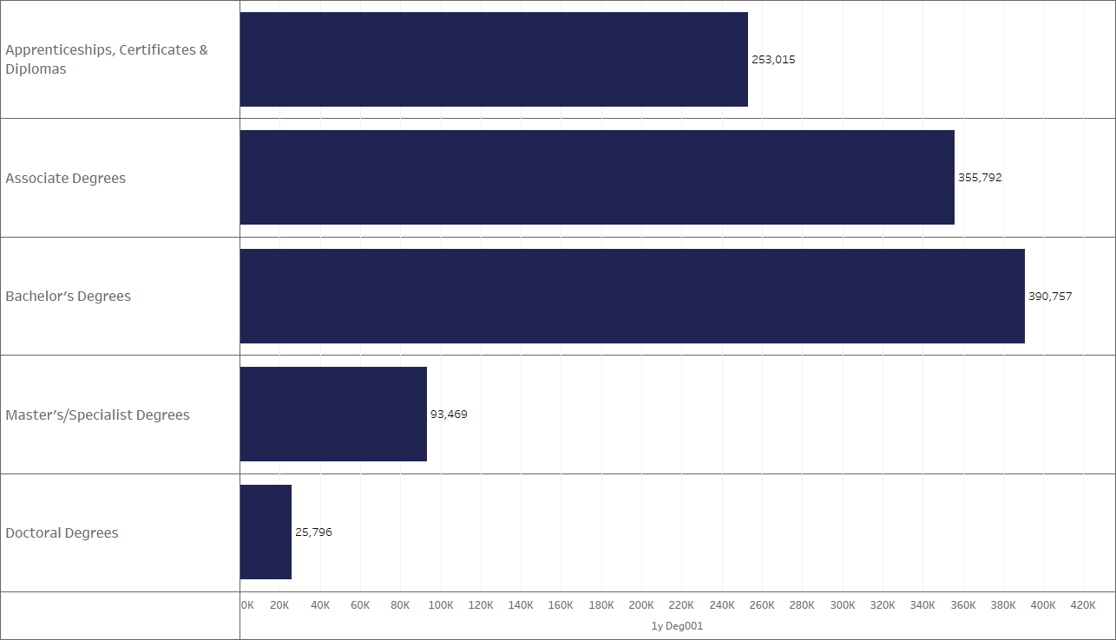

Outcomes at a Glance
- From 2017-18 through 2021-22, there were more than 390,000 bachelor’s degrees awarded at FCS and SUS institutions combined and more than 355,000 associate degrees at FCS institutions. Among those graduates, more than 281,000 received associate in arts degrees. Master’s degrees totaled more than 92,000 graduates, and there were more than 14,600 doctoral degrees conferred, excluding law and medical fields. College credit and career certificates combined totaled more than 185,000 graduates in DTCs.
- Broken down by county, institutions located in Orange County accounted for more than 162,000 awards from 2017-18 through 2021-22. Miami-Dade County accounted for more than 160,000 awards, while Hillsborough County placed more than 100,000 awards.
- Undergraduate job placement ranged from 67% to 93% of graduates found in employment data one year after graduation. After five years, the range narrowed to between 73% and 92%.
- Among the award programs designed to further education, 68% of graduates of associate in arts degrees, 58% of college credit certificate recipients and 47% of applied technology diploma recipients were found in education data one year after completion. Five years after graduation, these numbers fell to 15%, 13% and 19%, respectively.
- Median earnings one year after completion ranged from $33,000 to more than $53,000 for undergraduate programs, and $59,000 to nearly $80,000 for master’s and doctoral degrees. Some specific medical degrees, first professional and other doctoral programs exceeded $100,000.
- In popularity, business administration and management programs accounted for more than 66,000 total graduates from 2017-18 through 2021-22. Registered nursing totaled more than 52,000. Psychology programs totaled more than 29,000 recipients. Biology/Biological Sciences and Emergency Medical Technicians and EMT Paramedics totaled more than 18,000 and 17,000 graduates respectively.
- In academic year 2021-22 alone, there were 18,150 graduates from programs that align closely with the manufacturing industry. Job placement within one year of graduation for these programs ranged from 66.7% (Bachelor’s in Laser and Optical Engineering) to 100% (Associate in Science in Operations Management and Supervision).
- From 2017-18 through 2021-22, there were nearly 144,000 graduates who received awards in Science, Technology, Engineering and Math (STEM) fields.

Experience
Figure 2 displays the median first- and fifth-year salaries for all credentials awarded by Florida’s public postsecondary education system. The outcomes of all five major credential groups showed median fifth-year earnings that were 34% to 48% higher than first-year earnings. Doctoral degrees demonstrate a higher earning potential, with median fifth-year earnings totaling more than 46% higher than first-year earnings and 62% higher than fifth-year earnings of bachelor’s programs. Fifth-year earnings for bachelor’s degrees were 48% higher than first-year earnings.
Figure 2. Median First- and Fifth-Year Earnings by Credential, All Institutions
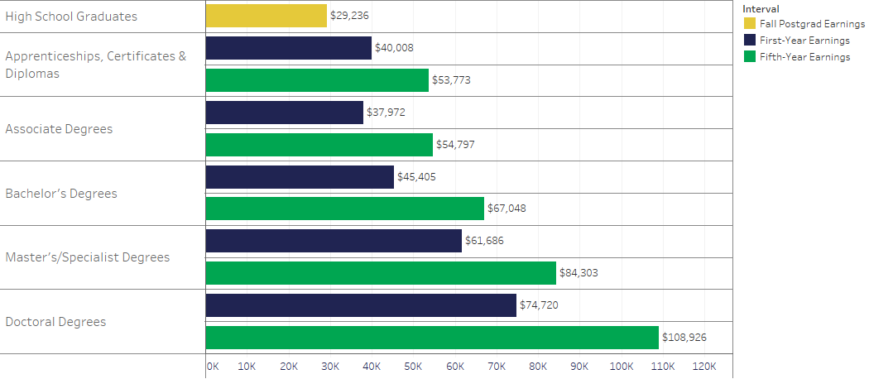

Progress
This report compares outcomes over five academic years, 2017-18 through 2021-22. However, we can also compare outcomes across previous periods to mark progress. The total number of credentials awarded increased across all credential categories compared to the previous report, 2016-17 through 2020-21. This progress can be seen in Table 1. Progress in median first-year earnings by year is shown in Figure 3.
- 253,015 certificates, diplomas and apprenticeships were awarded between 2017-18 and 2021-22, an increase of 4.6% from the total number of credentials awarded (241,820) in the previous economic security report, 2016-17 through 2020-21.
- Median first-year earnings for 2017-18 through 2021-22 increased between 3% for apprenticeships and 9.2% for applied technology diplomas at DTCs compared to 2016-17 through 2020-21.
- Median first-year earnings of associate degrees increased between 4.6% for associate in science degrees to 6.7% for associate in applied science degrees 2017-18 through 2021-22 compared to 2016-17 through 2020-21.
- There were 390,757 bachelor’s degrees awarded from 2017-18 through 2021-22, an increase of 2.7% from 2016-17 through 2020-21 (380,382).
- Median first-year earnings for bachelor’s degrees at FCS and SUS institutions increased between 4.6% and 5.6% from 2016-17 through 2020-21 to 2017-18 through 2021-22.
- There were 92,221 master’s degrees awarded from 2017-18 through 2021-22, an increase of 4.5% from 2016-17 through 2020-21 (88,265).
- Median first-year earnings for master’s degrees increased 4.8% in 2017-18 through 2021-22 from 2016-17 through 2020-21.
- There were 14,693 nonmedical doctoral degrees conferred this period, an increase of 4.6% in 2017-18 through 2021-22 from 2016-17 through 2020-21 (14,053).
- Median first-year earnings of nonmedical doctoral degrees increased 5.9% in 2017-18 through 2021-22 compared to 2016-17 through 2020-21.

Table 1. Progress in Outcomes by Credential Type from Previous Report
 | Awards Conferred |  |  | Median First-Year Earnings
Credential Type | 2016-17 through 2020-21 | 2017-18 through 2021-22 | Percent Change | 2016-17 through 2020-21 | 2017-18 through 2021-22 | Percent Change
Career Certificates (DTC) | 79,427 | 82,984 | 4.5% | $33,556 | $35,384 | 5.4%
Career Certificates (FCS) | 41,025 | 39,881 | -2.8% | $43,312 | $45,880 | 5.9%
College Credit Certificates | 95,825 | 102,296 | 6.8% | $37,840 | $39,800 | 5.2%
Applied Technology Diplomas (DTC) | 3,281 | 3,441 | 4.9% | $32,660 | $35,678 | 9.2%
Applied Technology Diplomas (FCS) | 5,524 | 5,179 | -6.2% | $32,598 | $35,009 | 7.4%
Apprenticeships (DTC) | 13,943 | 16,144 | 15.8% | $46,909 | $48,296 | 3.0%
Apprenticeships (FCS) | 830 | 851 | 2.5% | $48,754 | $50,480 | 3.5%
Advanced Technical Certificates | 1,965 | 2,239 | 13.9% | $51,018 | $53,162 | 4.2%
Associate in Applied Science Degrees | 597 | 484 | -18.9% | $37,454 | $39,980 | 6.7%
Associate in Science Degrees | 73,473 | 73,536 | 0.1% | $50,736 | $53,056 | 4.6%
Associate in Arts Degrees | 285,345 | 281,772 | -1.3% | $31,400 | $33,120 | 5.5%
Bachelor’s Degrees (FCS) | 45,911 | 48,577 | 5.8% | $51,208 | $53,548 | 4.6%
Bachelor’s Degrees (SUS) | 334,471 | 342,180 | 2.3% | $41,764 | $44,092 | 5.6%
Master’s Degrees | 88,265 | 92,221 | 4.5% | $58,860 | $61,667 | 4.8%
Doctoral Degrees (Nonmedical) | 14,053 | 14,693 | 4.6% | $75,572 | $79,996 | 5.9%

Figure 3. Median First-Year Earnings by Degree Type and Single Year, 2017-2021
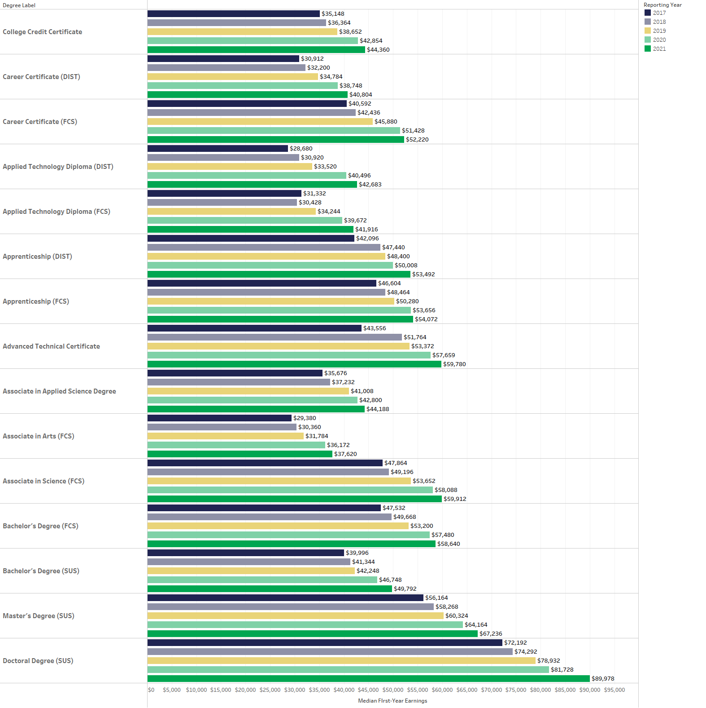

Student Debt
FCS and SUS institutions in Florida self-report student loan debt data to the Office of Student Financial Assistance in the Florida Department of Education. A total of $1.47 billion was granted across 233,244 federal student loans, including all students who received Stafford, Perkins, Graduate PLUS, Parent PLUS and TEACH program loans, and dispersed to FCS and SUS institutions in 2021-22. This excludes Chipola College and North Florida College where data were not reported.
The statewide average during the 2021-22 academic year was $6,286 per loanee. This amount is averaged across all students that received federal student loans and does not include private loans or other debt issued by non-federal government sources.

Public Assistance
During this reporting period, from 2017-18 through 2021-22, public universities in Florida reported the fewest number of graduates receiving public assistance in at least seven years (2011-12 through 2015-16 reporting period), the oldest data available. During the reporting period, 60,597 students (5.4%) received assistance from either the Temporary Assistance for Needy Families (TANF) program or the Supplemental Nutrition Assistance Program (SNAP) one year after graduation. This is a 28% decrease from 84,573 students (7.7%) during 2016-17 through 2020-21.

Labor Market
As Florida’s population continues to increase, so too will the available jobs. A healthy job market will assist graduates of Florida institutions in their efforts to begin careers of their choosing. The industries expected to gain the most jobs through 2032 are Professional and Technical Services (+93,903 jobs), Ambulatory Health Care Services (+70,264 jobs) and Administrative and Support Services (+68,674 jobs). Collectively, the top 10 industries in job growth are anticipated to add more than 400,000 new jobs through 2032. The occupations expected to experience the largest job growth through 2032 are General and Operations Managers (+12,517), Software Developers (+10,665) and Heavy and Tractor-Trailer Truck Drivers (+9,673). Chiropractors (+17.1% growth) is the occupation projected to be fastest growing through 2032.
At least every three years, the Florida Department of Commerce updates its Target Industry Report. The Target Industry List identified in 2025 is comprised of those industries that drive growth, innovation and resilience across Florida’s economy. Each of these industries are current sources of job demand, and job growth is expected to continue through 2032.
For 2025, the Target Industries List includes the following industry sectors: Corporate Headquarters, Logistics, Manufacturing, Research and Development, Aerospace and Aviation, AgTech, Energy Security, Financial Services, Information Technology, Life Sciences, Maritime, and Military and Defense. As a Target Industry focus, Manufacturing employment in Florida totaled nearly 430,000 at the end of 2024 – an increase of over 29% since 2014. Employment within the manufacturing industry is expected to total over 458,000 by 2033. Collectively, Target Industry wages increased 11.5 percent from 2022 to 2024, compared with 8.9% growth across all industries. Over-the-year growth for Target Industry wages was 5.7% in 2023 and 5.4% in 2024, consistently representing a premium over statewide wages.

Certificates, Diplomas and Apprenticeships
Career and adult education programs are designed to meet the needs of students and business/industry with a mission to provide educational opportunities and training necessary to prepare students to meet the needs and standards of today’s competitive workplace. During the five-year period covered within this report, more than 253,000 students completed a certificate, diploma or apprenticeship at one or more of Florida’s DTC or FCS institutions (22% of all certifications/degrees awarded in Florida). The following subsections present a summary of each.
Certificate Programs | Certificate programs are available in many specialties for students who want to spend less than two years in career preparation. Two types of certificate programs are offered at Florida’s postsecondary institutions:
Career certificate programs are a series of vocational courses that prepare students for entry-level employment in specific career fields. Programs vary in length from 40 credit hours to more than 1,500 clock hours. Both FCS and DTC institutions offer these certificate programs as non-college credit. Examples of career certificates include correctional probation officers, cosmetologists, culinary operators, firefighters and practical nurses. Career certificates are also referred to as technical certificates.
College credit certificate programs are a series of postsecondary vocational courses that prepare students for entry-level employment in specific career fields or for career advancement. These are offered through institutions within the FCS. Generally, these certificates can be completed in one year or less and must be part of an associate in science (AS) or associate of applied science (AAS) degree program. Examples include information technology technician, office specialist, computer programmer and educational assistant. College credit certificates are also called postsecondary vocational certificates.
Applied Technology Diploma | The applied technology diploma is a course of study that is part of an AS or AAS degree program. The course of study is less than 60 credit hours and designed to lead to employment in a specific occupation. Examples include dental assistant and emergency medical technician. An applied technology diploma may consist of career and technical education credit (clock hours) or college credit. When a student is seeking an applied technology diploma at a DTC or in a clock-hour program at a college, clock hours are converted to semester hours if the student enters the AS or AAS degree program.
Apprenticeship | An apprenticeship is a combination of on-the-job training and related classroom instruction in which a student learns the practical and theoretical aspects of a highly skilled occupation. Programs are sponsored by apprenticeship organizations in partnership with DTC and FCS institutions, although the majority are through DTCs. It should be noted that students are employed as part of their apprenticeship.

Certificate Outcomes
Graduates of certificate programs, on average, had higher first-year earnings than graduates with associate of arts (AA) degrees. The median first-year earnings of graduates with AA degrees ($33,120) were lower than those of graduates with career certificates ($39,096) or college credit certificates ($39,800). However, graduates of certificate courses, on average, had lower median first-year earnings than graduates with AS degrees ($53,056). Together, Florida’s FCS and DTC institutions awarded more than 225,000 career and college credit certificates for the academic years of 2017-18 through 2021-22.

Career Certificate Programs
As shown in Table 2, 84% of career certificate graduates from FCS institutions were found in employment data one year post-completion with median first-year earnings of $45,880. Statewide median first-year earnings of graduates with career certificates from DTCs were $35,384, with 76% of graduates found in employment data one year after completion.

College Credit Certificates
Also shown in Table 2, the median first-year earnings of college credit certificates were $39,800 in 2017-18 through 2021-22, with 74% of recipients found within employment data one year after completion. Those students who received college credit certificates had comparable earnings to those who received career certificates. Students who completed college credit certificates were found in employment data less frequently one year after completion than students who earned career certificates.

Table 2. Employment Outcomes of Graduates with Career Certificates
Credential Type | Total Graduates | Median First-Year Earnings | Percentage Found in Employment Data After One Year | Median Fifth-Year Earnings | Percentage Found in Employment Data After Five Years
Career Certificate (DTC) | 82,984 | $35,384 | 76% | $47,298 | 73%
Career Certificate (FCS) | 39,881 | $45,880 | 84% | $61,836 | 81%
College Credit Certificate (FCS) | 102,296 | $39,800 | 74% | $55,108 | 79%

Also noteworthy, as shown in Figure 4 of this report, 58% of students receiving a college credit certificate are enrolled in subsequent education one year after completion.

Applied Technology Diploma Outcomes
As shown in Table 3, more than 8,600 applied technology diplomas were awarded in Florida in DTC and FCS institutions combined during the reporting period. Median first-year earnings exceeded $35,000 with more than 83% of all DTC and FCS graduates found within earnings data one year after completion.
Table 3. Employment Outcomes of Graduates with Applied Technology Diplomas
Credential Type | Total Graduates | Median First-Year Earnings | Percentage Found in Employment Data After One Year | Median Fifth-Year Earnings | Percentage Found in Employment Data After Five Years
Applied Technology Diplomas (DTC) | 3,441 | $35,678 | 84% | $46,544 | 80%
Applied Technology Diplomas (FCS) | 5,179 | $35,009 | 83% | $57,448 | 84%

Apprenticeship Outcomes
As shown in Table 4, 95% of apprenticeships are offered through DTCs with nearly 17,000 total apprenticeships awarded. When combined, the median first-year earnings of all DTC and FCS graduates totaled $48,405, with more than 82% found within employment data one year after completion.
Table 4. Employment Outcomes of Graduates with Apprenticeships
Credential Type | Total Graduates | Median First-Year Earnings | Percentage Found in Employment Data After One Year | Median Fifth-Year Earnings | Percentage Found in Employment Data After Five Years
Apprenticeship (DTC) | 16,144 | $48,296 | 82% | $57,320 | 75%
Apprenticeship (FCS) | 851 | $50,480 | 93% | $61,330 | 84%

What Students Study
Table 5 presents student outcomes for the most popular career certificate programs offered by DTCs. Median first-year earnings ranged from $27,964 (Cosmetology) to $50,486 (Law Enforcement Officer) for programs with the most graduates.
The top 10 median first-year earnings ranged from nearly $48,000 (Wastewater Treatment Technologies) to almost $61,000 (Electrical and Instrumentation Technology) for programs offering career certificates at DTCs.
Table 5. First- and Fifth-Year Employment Outcomes for Graduates of 10 Most Popular Career Certificates Awarded by District Technical Centers
Program | Total Graduates | Median First-Year Earnings | Percentage Found in Employment Data After One Year | Median Fifth-Year Earnings | Percentage Found in Employment Data After Five Years
Practical Nursing | 8,081 | $40,380 | 86% | $56,670 | 84%
Cosmetology | 5,149 | $27,964 | 66% | $36,512 | 61%
Welding Technology | 3,684 | $37,029 | 75% | $49,204 | 72%
Electricity | 2,363 | $34,772 | 75% | $48,968 | 75%
Medical Assisting | 2,355 | $30,106 | 80% | $37,272 | 80%
Florida Law Enforcement Academy | 2,328 | $50,486 | 91% | $67,065 | 86%
Professional Culinary Arts and Hospitality | 2,291 | $28,260 | 72% | $36,444 | 69%
Phlebotomy | 2,127 | $31,392 | 77% | $40,636 | 74%
Commercial Vehicle Driving | 2,116 | $46,656 | 71% | $59,460 | 58%
Automotive Service Technology | 1,954 | $32,232 | 78% | $47,106 | 72%
As shown in Table 6, the differences in first-year earnings varied greatly between the popular certificate programs at FCS institutions. Median first-year earnings of the most popular career certificates offered in the Florida College System varied from $27,648 (Cosmetology) to $55,664 (Florida Law Enforcement Officers).
The range for top programs based on first-year earnings was nearly $48,000 (Police Service Aide) to more than $55,600 (Florida Law Enforcement Officers).
Table 6. First- and Fifth-Year Employment Outcomes for Graduates of 10 Most Popular Career Certificates Awarded by the Florida College System
Program | Total Graduates | Median First-Year Earnings | Percentage Found in Employment Data After One Year | Median Fifth-Year Earnings | Percentage Found in Employment Data After Five Years
Florida Law Enforcement Academy | 8,876 | $55,664 | 92% | $71,862 | 89%
Correctional Officer | 3,057 | $51,290 | 96% | $65,898 | 91%
Firefighter | 2,849 | $45,820 | 90% | $68,252 | 91%
Insurance Claims Adjuster | 1,665 | $48,548 | 77% | $60,804 | 71%
Cosmetology | 1,639 | $27,648 | 69% | $41,118 | 57%
Insurance Customer Service Representative | 1,237 | $34,684 | 81% | $48,222 | 75%
Practical Nursing | 1,221 | $43,636 | 91% | $57,308 | 88%
Welding Technology | 1,191 | $38,031 | 80% | $54,940 | 80%
Phlebotomy | 1,165 | $30,976 | 78% | $42,616 | 76%
Commercial Vehicle Driving | 1,047 | $46,564 | 77% | $61,304 | 67%
Table 7 identifies the median first-year earnings outcomes of graduates with the most popular college credit certificates. Earnings among the most popular college credit certificates range from $30,040 (Child Care) to $46,150 (Chemical Technology).
Among the highest-earning college credit certificates, the range was more than $50,900 (Electrical and Power Transmission Installation) to nearly $82,000 (Fire Prevention and Safety Technology).

Table 7. First- and Fifth-Year Employment Outcomes for Graduates of 10 Most Popular College Credit Certificates Awarded by the Florida College System
Program | Total Graduates | Median First-Year Earnings | Percentage Found in Employment Data After One Year | Median Fifth-Year Earnings | Percentage Found in Employment Data After Five Years
Business Administration and Management, General | 35,673 | $38,868 | 72% | $53,924 | 77%
Emergency Medical Technology/Technician (EMT Paramedic) | 10,858 | $44,988 | 86% | $67,310 | 86%
Accounting Technology/Technician and Bookkeeping | 9,597 | $40,050 | 74% | $55,744 | 79%
Operations Management and Supervision | 7,235 | $40,762 | 73% | $49,720 | 79%
Entrepreneurship/ Entrepreneurial Studies | 6,658 | $41,672 | 73% | $52,858 | 76%
Information Technology | 3,449 | $41,916 | 73% | $58,056 | 78%
Chemical Technology/Technician | 3,366 | $46,150 | 75% | $64,315 | 85%
Network and System Administration/Administrator | 2,970 | $44,392 | 76% | $62,078 | 78%
Child Care Provider/Assistant | 2,685 | $30,040 | 74% | $37,680 | 77%
Small Business Administration/Management | 2,611 | $41,010 | 72% | $55,064 | 79%

Applied Technology Diplomas are offered in 12 programs in both DTCs and FCS institutions. Outcomes for the most popular programs are shown in Tables 8A and 8B by educational system. Certificates related to EMT and Dental Assistants were common in both systems, with EMT median first-year earnings ranging between $35,334 and $36,128, and dental assistants’ median first-year earnings ranging between $30,364 and $32,114. The highest fifth-year earnings for ATD programs were found with graduates of EMT programs at FCS institutions ($58,860).

Table 8. First- and Fifth-Year Employment Outcomes for Graduates of an Applied Technology Diploma
- FCS
Program | Total Graduates | Median First-Year Earnings | Percentage Found in Employment Data After One Year | Median Fifth-Year Earnings | Percentage Found in Employment Data After Five Years
Emergency Medical Technology/Technician (EMT Paramedic) | 4,607 | $36,128 | 83% | $58,860 | 84%
Dental Assisting/Assistant | 393 | $32,114 | 80% | $42,612 | 84%
Pharmacy Technician/Assistant | 135 | $31,044 | 81% | $41,296 | 83%
Health Information/Medical Records Technology/Technician | 25 | $28,734 | 80% | $42,456 | 71%
- DTC
Program | Total Graduates | Median First-Year Earnings | Percentage Found in Employment Data After One Year | Median Fifth-Year Earnings | Percentage Found in Employment Data After Five Years
Emergency Medical Technician – ATD | 1,705 | $35,334 | 83% | $53,312 | 83%
Dental Assisting Technology and Management – ATD | 472 | $30,364 | 88% | $37,236 | 82%
Medical Code/Biller – ATD | 409 | $31,660 | 80% | $44,573 | 78%
Paramedic – ATD | 288 | $59,250 | 95% | NA¹ | NA¹
Pharmacy Technician – ATD | 221 | $29,614 | 81% | $44,196 | 75%
Medical Clinical Laboratory Technician – ATD | 131 | $43,304 | 85% | $51,840 | 66%
¹ Fifth-year outcomes not available.

Only 10 total apprenticeships programs were offered across nine FCS institutions. Outcomes for the five most popular programs are shown in Table 9. Apprenticeships in Heating, Air Conditioning, Ventilation and Refrigeration Maintenance programs had the highest fifth-year earnings ($78,512) among these. Child Care Provider/Assistant program graduates had the lowest fifth-year earnings ($30,774).
Table 9. First- and Fifth-Year Employment Outcomes for Graduates of Apprenticeships Awarded by the Florida College System
Program | Total Graduates | Median First-Year Earnings | Percentage Found in Employment Data After One Year | Median Fifth-Year Earnings | Percentage Found in Employment Data After Five Years
Electrician | 504 | $48,986 | 95% | $61,800 | 88%
Pipefitting/Pipefitter and Sprinkler Fitter | 105 | $54,380 | 97% | $60,256 | 92%
Plumbing Technology/Plumber | 97 | $60,436 | 98% | $67,556 | 90%
Heating, Air Conditioning, Ventilation and Refrigeration Maintenance Technology/Technician | 84 | $53,690 | 89% | $78,512 | 72%
Carpentry/Carpenter | 21 | $40,832 | 67% | $51,436 | 60%
Child Care Provider/Assistant | 21 | $26,115 | 67% | $30,774 | 67%

Table 10 shows first- and fifth-year employment outcomes for apprenticeship graduates in the most popular programs at DTC institutions.
Among the most popular apprenticeship programs, Electric Line Service and Repair had the highest first-year earnings ($80,346) while Elevator Constructor Mechanic apprenticeships had the highest median first-year earnings among all programs ($97,342). Graduates of Early Childhood Education had the lowest median fifth-year earnings ($34,824).
Table 10. First- and Fifth-Year Employment Outcomes for Graduates of 10 Most Popular Apprenticeships Awarded by District Technical Centers
Program | Total Graduates | Median First-Year Earnings | Percentage Found in Employment Data After One Year | Median Fifth-Year Earnings | Percentage Found in Employment Data After Five Years
Electrician | 5,690 | $46,450 | 84% | $55,328 | 77%
Plumbing Technology | 1,824 | $51,584 | 83% | $65,416 | 74%
Air Conditioning, Refrigeration and Heating Technology | 1,612 | $50,676 | 87% | $64,720 | 83%
Early Childhood Education | 1,450 | $25,768 | 75% | $34,824 | 67%
Carpentry | 774 | $44,332 | 71% | $53,850 | 66%
Structural Steel Work | 601 | $54,568 | 81% | $58,888 | 78%
Electrical Line Service and Repair | 467 | $80,346 | 86% | $98,078 | 73%
Brick and Block Masonry | 412 | $35,460 | 66% | $49,480 | 66%
Firefighter | 392 | $64,644 | 92% | $82,140 | 95%
Heavy Equipment Operation | 332 | $69,844 | 80% | $93,624 | 79%

Certificate, Diploma and Apprenticeship Students Continuing Their Education
Figure 4 shows the percentage of graduates found in the education enrollment records one and five years after completion in apprenticeship, certificate or diploma programs who were enrolled in some form of subsequent education.
At DTCs, recipients of applied technology diplomas were most frequently found continuing their education one year after graduation (16%). 14% of career certificate recipients and 6% of apprentices were found continuing their education one year after receiving their awards.
In the Florida College System, recipients of college credit certificates were most likely to be found continuing their education after one year (58%), with 47% of applied technology diploma recipients and 22% of career certificate recipients pursuing additional education after one year.
Figure 4. Percentage of Graduates Continuing Their Education After One and Five Years
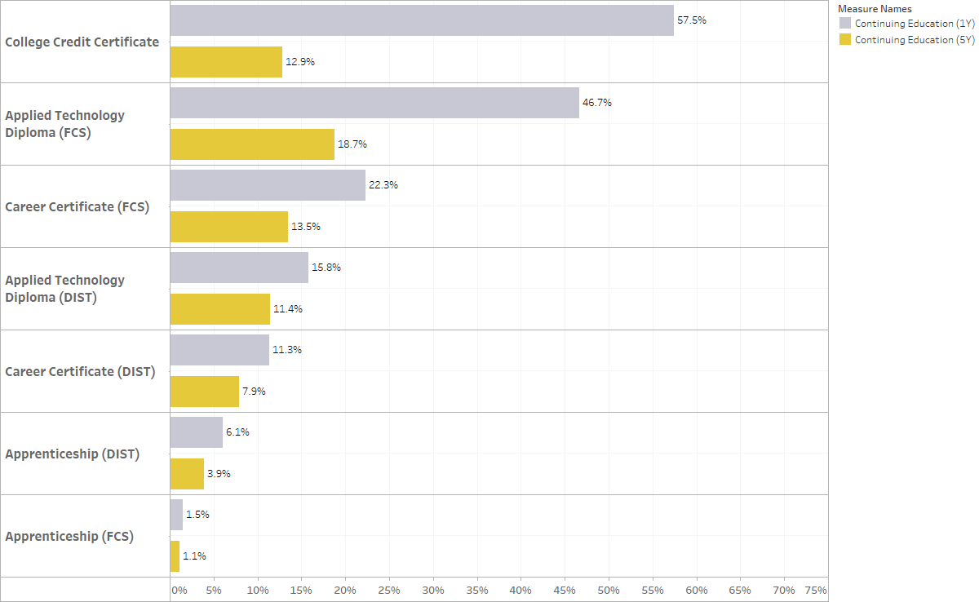

Associate Degrees
The associate degree is a two-year college credit degree/program. Within Florida’s public educational system, there are four different types of associate degrees and certificates, differentiated by student career interest. Over the five-year period covered within this report, academic years 2017-18 through 2021-22, more than 355,000 students were awarded an associate degree or advanced technical certificate from one or more of these institutions, accounting for one-third of all graduates. Below is a summary of each type of associate degree/certificate.
Associate in Arts | The AA degree is a two-year liberal arts degree designed to prepare students who are planning to earn a bachelor’s degree. It serves as a basis for admission to a bachelor’s degree program.
Associate in Science | The AS degree is a two-year technical degree designed to prepare students who are planning to enter a specific occupation. It serves as a basis for admission to a related bachelor’s degree program.
Associate in Applied Science | The AAS degree is a two-year technical degree designed to train students for direct entry into a specialized occupation in the workplace. AAS degrees are designed for students who do not wish to pursue education beyond an associate level degree.
Advanced Technical Certificate | ATC programs of instruction are less than 45 credit hours of college-level courses. ATCs are awarded to students who have already received an AS or AAS degree and are seeking an advanced specialized planning program of study to supplement their associate degree.
As Figure 1 of this report shows, the associate degree is the second most awarded postsecondary credential in Florida (approximately 33% of all certificates/degrees awarded). Table 11 shows that among associate degrees, AA degrees are the most common. The AA degree is designed as a pathway to a bachelor’s degree. Compared with the AA degree, fewer students completed career- and technical-oriented degree programs of study.

Associate in Arts Degree Outcomes
Among the types of associate degrees, the most common in Florida is the AA with 281,772 degrees awarded during the five-year study period. As shown in Table 11, the median first-year earnings of all graduates with AA degrees were $33,120.

Associate in Science Degree Outcomes
After the AA degree, the next most common associate degree awarded in Florida is the AS degree. During the five-year study period, 73,536 AS degrees were awarded. The median first-year earnings for AS degrees of $53,056 were the highest out of all associate degree types.

Associate in Applied Science Degree Outcomes
A total of 484 students in Florida earned AAS degrees from academic years 2017-18 through 2021-22. The AAS degree program trains students for direct entry into a specialized occupation and is designed for students who choose not to pursue education beyond an associate level degree.
The median statewide first-year earnings of graduates with AAS degrees were $39,980, approximately $6,800 higher than those of graduates with AA degrees ($33,120), but more than $13,000 lower than those with AS degrees ($53,056).

Advanced Technical Certificate Outcomes
Those receiving ATCs achieved the highest median first-year earnings in 2017-18 through 2021-22 among this group of credentials. Earnings for ATCs were narrowly higher than AS degrees in FCS institutions ($53,162 versus $53,056). ATCs are generally designed for individuals who have already completed a two-year AS or AAS degree and are seeking advanced, specialized preparation in a particular career field to supplement their degree. ATCs are offered at 14 of the 28 FCS institutions. A total of 2,239 ATCs were awarded from 2017-18 through 2021-22.

Table 11. Employment Outcomes for Graduates with Associate Degrees and Advanced Technical Certificates
Degree | Total Graduates | Median First-Year Earnings | Percentage Found in Employment Data After One Year | Median Fifth-Year Earnings | Percentage Found in Employment Data After Five Years
AA Degree | 281,772 | $33,120 | 67% | $51,640 | 78%
AS Degree | 73,536 | $53,056 | 83% | $66,280 | 84%
ATC | 2,239 | $53,162 | 84% | $62,216 | 84%
AAS Degree | 484 | $39,980 | 79% | $57,987 | 78%

What Students Study
Graduates with AA degrees are classified into a single program of study (liberal arts and sciences/liberal studies). However, AAS and AS degrees offer a variety of more specific programs of study. Table 12 shows the first- and fifth-year outcomes for graduates of the most popular AS degree programs. Registered Nursing/Registered Nurse AS graduates outnumber graduates of the second-most popular program (Business Administration and Management) by more than 20,000. Registered Nursing also is one of the highest paying of the common AS degree programs, with median first-year earnings of $61,376. The highest earnings among the most popular programs listed in Table 12 were found among graduates of EMT Paramedic programs ($70,024).
There is a large range of earnings with AS awards, starting with Equestrian/Equine Studies ($26,892) on the low end to Physician Assistant awards ($96,920) on the high end. Furthermore, there is a large range of graduates found within employment data, ranging from 50% (Teacher Assistant/Aide) to 94% (Medical Radiologic Technology/Science – Radiation Therapist) one year after completion.

Table 12. First- and Fifth-Year Employment Outcomes for Graduates of 10 Most Popular AS Degrees
Program | Total Graduates | Median First-Year Earnings | Percentage Found in Employment Data After One Year | Median Fifth-Year Earnings | Percentage Found in Employment Data After Five Years
Registered Nursing/Registered Nurse | 24,208 | $61,376 | 92% | $79,631 | 90%
Business Administration and Management, General | 3,982 | $40,752 | 76% | $53,318 | 79%
Criminal Justice/Law Enforcement Administration | 2,946 | $40,944 | 81% | $55,568 | 82%
Emergency Medical Technology/Technician (EMT Paramedic) | 2,061 | $70,024 | 95% | $91,552 | 93%
Legal Assistant/Paralegal | 2,015 | $39,100 | 80% | $53,637 | 77%
Information Technology | 1,833 | $41,056 | 74% | $58,735 | 79%
Network and System Administration/Administrator | 1,797 | $44,408 | 78% | $62,376 | 81%
Computer Programming/Programmer, General | 1,735 | $43,582 | 69% | $66,512 | 79%
Medical Radiologic Technology/Science – Radiation Therapist | 1,729 | $50,936 | 93% | $64,080 | 92%
Physical Therapy Technician/Assistant | 1,688 | $42,036 | 77% | $53,126 | 76%
Employment Outcomes data exist for only five AAS degree programs. Table 13 shows outcomes for those programs by number of graduates from 2017-18 through 2021-22. Median first-year earnings ranged from $28,572 (Diver, Professional and Instructor) to $49,824 (Electrical and Power Transmission Installation/Installer, General).
Table 13. First- and Fifth-Year Employment Outcomes for Graduates of the Most Popular AAS Degrees
Program | Total Graduates | Median First-Year Earnings | Percentage Found in Employment Data After One Year | Median Fifth-Year Earnings | Percentage Found in Employment Data After Five Years
Automotive Engineering Technology/Technician | 303 | $37,948 | 82% | $55,762 | 84%
Diesel Mechanics Technology/Technician | 103 | $40,812 | 70% | $66,588 | 62%
Diver, Professional and Instructor | 24 | $28,572 | 71% | $60,678 | 50%
Heating, Ventilation, Air Conditioning and Refrigeration Engineering Technology/Technician | 21 | $41,348 | 76% | $42,592 | 50%
Electrical and Power Transmission Installation/Installer, General | 20 | $49,824 | 90% | $133,402 | 100%
ATCs are currently offered in 30 programs. Table 14 shows outcomes for the 10 most popular programs by number of graduates. First-year earnings varied considerably from $38,673 (Environmental Science) to $77,902 (Registered Nursing).
Among all programs, earnings range from $34,752 (Baking and Pastry Arts/Baker/Pastry Chef) to $77,902 (Registered Nursing).

Table 14. First- and Fifth-Year Employment Outcomes for the 10 Most Popular ATC Programs
Program | Total Graduates | Median First-Year Earnings | Percentage Found in Employment Data After One Year | Median Fifth-Year Earnings | Percentage Found in Employment Data After Five Years
Medical Radiologic Technology/Science – Radiation Therapist | 330 | $60,948 | 94% | $77,198 | 97%
Business Administration and Management, General | 314 | $45,504 | 83% | $59,970 | 86%
Legal Assistant/Paralegal | 223 | $43,068 | 84% | $58,656 | 82%
Information Technology | 220 | $50,962 | 79% | $85,184 | 88%
Health/Health Care Administration/Management | 217 | $42,044 | 80% | $54,812 | 77%
Computer and Information System Security/Information Assurance | 195 | $48,116 | 83% | $70,762 | 85%
Environmental Science | 120 | $38,673 | 74% | $43,636 | 72%
Radiologic Technology/Science – Radiographer | 97 | $68,440 | 98% | NA¹ | NA¹
Registered Nursing/Registered Nurse | 82 | $77,902 | 95% | $94,922 | 100%
Funeral Service and Mortuary Science, General | 82 | $60,512 | 77% | $60,300 | 53%
¹ Data for fifth-year earnings and employment is unavailable. Some data are suppressed for privacy reasons.

Associate Degree Students Continuing Their Education
Figure 5 shows the percentage of associate degree graduates found in the education enrollment data one- and five-years after completion. Most undergraduate degrees are intended to begin a career after completion. However, AA degrees were generally designed as a starting block for further study. AA degree graduates had the highest proportion of enrollment in subsequent education one year after graduation (68.1%), followed by AS degree graduates (36.1%) and graduates of ATC (21.2%) and AAS degrees (18%). Five years after completion, subsequent education enrollment rates ranged from 7.4% for ATC graduates to 15% for AA degree graduates.

Figure 5. Percentage of Associate Degree and ATC Graduates Continuing Their Education After One and Five Years
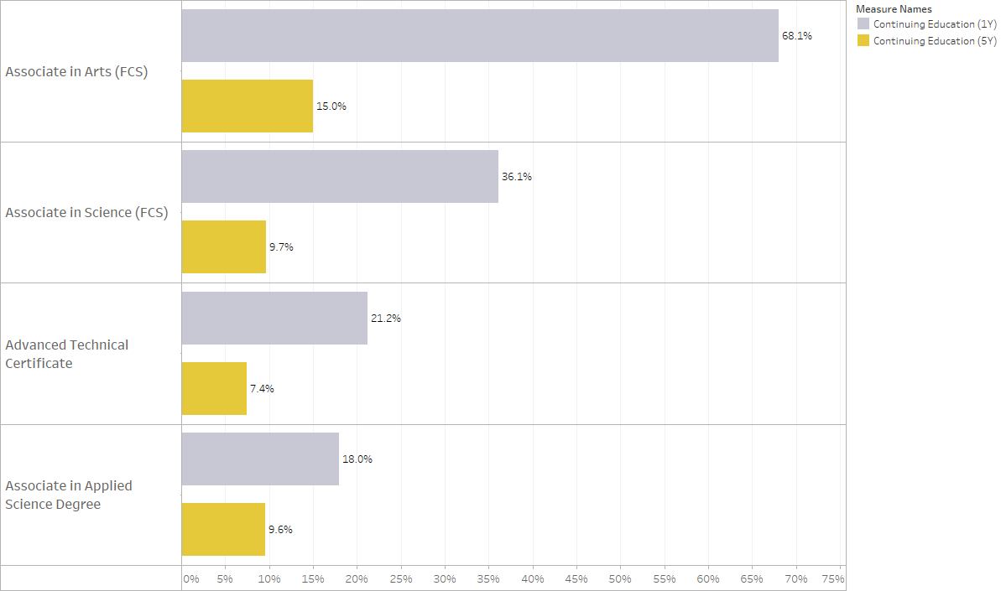

Bachelor’s Degrees
The bachelor’s degree is a four-year degree that is typically 120 credit hours. It may have an emphasis on science and liberal arts or accommodate unique demands for entry into specific workforce sectors. The bachelor’s degree is the most common degree awarded in Florida. According to data from the United States Census Bureau’s American Community Survey, graduates with bachelor’s degrees nationwide in 2021 had median earnings exceeding 74% more than those of high school graduates ($35,019 for high school graduates and $61,073 for bachelor’s degree graduates). In Florida, the difference was 62% ($31,711 for high school graduates and $51,381 for bachelor’s degree graduates). In the Florida public postsecondary educational system, bachelor’s programs are offered at both SUS institutions and many FCS institutions. During the five-year period covered within this report, academic years 2017-18 through 2021-22, more than 390,000 students completed a bachelor’s degree at one of these institutions, which accounts for nearly 35% of all awards issued across the five cohort years.

Bachelor’s Degree Outcomes
In many states, including Florida, two-year colleges award bachelor’s degrees. The authority to award bachelor’s degrees is usually limited to more technical areas aligned with the career orientation of certificates and associate degrees core to the mission of two-year colleges. Shown in Table 15, during the five-year study period, FCS institutions awarded 12% of all bachelor’s degrees granted in 2017-18 through 2021-22 (48,577), while the 12 institutions comprising the SUS accounted for the other 88% (342,180).
Table 15. Employment Outcomes for Graduates with Bachelor’s Degrees
Name | Total Graduates | Median First-Year Earnings | Percentage Found in Employment Data After One Year | Median Fifth-Year Earnings | Percentage Found in Employment Data After Five Years
Bachelor’s Degree (FCS) | 48,577 | $53,548 | 85% | $67,284 | 82%
Bachelor’s Degree (SUS) | 342,180 | $44,092 | 75% | $67,016 | 79%
Total | 390,757 | $45,364 | 75% | $67,048 | 79%

What Students Study
From 2017-18 through 2021-22, there were a total of nearly 300 different bachelor’s degree programs offered between FCS and SUS institutions, with at least three dozen being offered in both institution types. Among the 10 most popular FCS bachelor’s degrees (see Table 16), the highest first-year earnings were found with a Registered Nursing/Registered Nurse degree ($74,164). Along with Elementary Education and Teaching, graduates of Registered Nurse programs also had the highest job placement one year after graduation among the most popular programs, with 94% being found in the employment records.
Among all programs, the earnings ranged from $37,074 on the low end for recipients of Animation, Interactive Technology, Video Graphics and Special Effects degrees to $76,964 on the high end for Respiratory Care Therapy/Therapist degrees.
As seen in Table 17, for SUS institutions, the highest earnings among the most popular programs were also seen in Registered Nursing/Registered Nurse degrees ($66,490), similar to the most popular FCS programs. Earnings among all programs at SUS institutions ranged from $24,602 for Photography degrees to $84,240 for Fire Science/Firefighting degrees.
Table 16. First- and Fifth-Year Employment Outcomes for Graduates of the 10 Most Popular FCS Bachelor’s Degrees
Program | Total Graduates | Median First-Year Earnings | Percentage Found in Employment Data After One Year | Median Fifth-Year Earnings | Percentage Found in Employment Data After Five Years
Business Administration, Management and Operations, Other | 15,523 | $46,200 | 81% | $60,688 | 80%
Registered Nursing/Registered Nurse | 10,231 | $74,164 | 94% | $93,568 | 89%
Business Administration and Management, General | 3,086 | $46,884 | 82% | $60,320 | 86%
Information Technology | 2,239 | $53,786 | 82% | $75,052 | 83%
Homeland Security, Law Enforcement, Firefighting and Related Protective Services, Other | 1,535 | $48,764 | 81% | $64,315 | 78%
Computer/Information Technology Services Administration and Management, Other | 1,254 | $56,608 | 82% | $74,664 | 82%
Elementary Education and Teaching | 1,231 | $45,260 | 94% | $54,108 | 86%
Human Services, General | 1,101 | $36,608 | 79% | $50,104 | 76%
Early Childhood Education and Teaching | 912 | $45,136 | 85% | $54,772 | 81%
Health Services Administration | 813 | $48,554 | 84% | $53,762 | 79%
Table 17. First- and Fifth-Year Employment Outcomes for Graduates of the 10 Most Popular SUS Bachelor’s Degrees
Program | Total Graduates | Median First-Year Earnings | Percentage Found in Employment Data After One Year | Median Fifth-Year Earnings | Percentage Found in Employment Data After Five Years
Psychology, General | 28,157 | $34,756 | 72% | $55,918 | 75%
Biology/Biological Sciences, General | 16,948 | $32,804 | 67% | $60,791 | 61%
Registered Nursing/Registered Nurse | 15,086 | $66,490 | 92% | $85,284 | 86%
Health Services/Allied Health/Health Services, General | 14,789 | $33,600 | 74% | $63,235 | 76%
Finance, General | 13,837 | $52,868 | 78% | $84,542 | 84%
Criminal Justice/Safety Studies | 11,923 | $37,628 | 76% | $59,616 | 79%
Marketing/Marketing Management, General | 11,409 | $45,830 | 78% | $75,268 | 84%
Business Administration and Management, General | 11,248 | $48,204 | 77% | $72,016 | 82%
Political Science and Government, General | 9,644 | $39,500 | 63% | $66,974 | 76%
Multi-/Interdisciplinary Studies, General | 9,561 | $40,000 | 76% | $56,792 | 81%

Bachelor’s Degree Students Continuing Their Education
As is the case nationwide, the bachelor’s degree is the highest degree that most students in Florida will attain. However, a minority of students completing their bachelor’s degree enrolled in subsequent education programs. Figure 6 displays these rates.
One year after graduation, 16% of bachelor’s recipients at SUS institutions were enrolled in subsequent education, compared to 7.9% at FCS institutions. Five years after graduation, those rates fell to 6.4% at SUS schools and 4.4% at FCS schools.

Figure 6. Percentage of Bachelor’s Degree Graduates Continuing Their Education After One and Five Years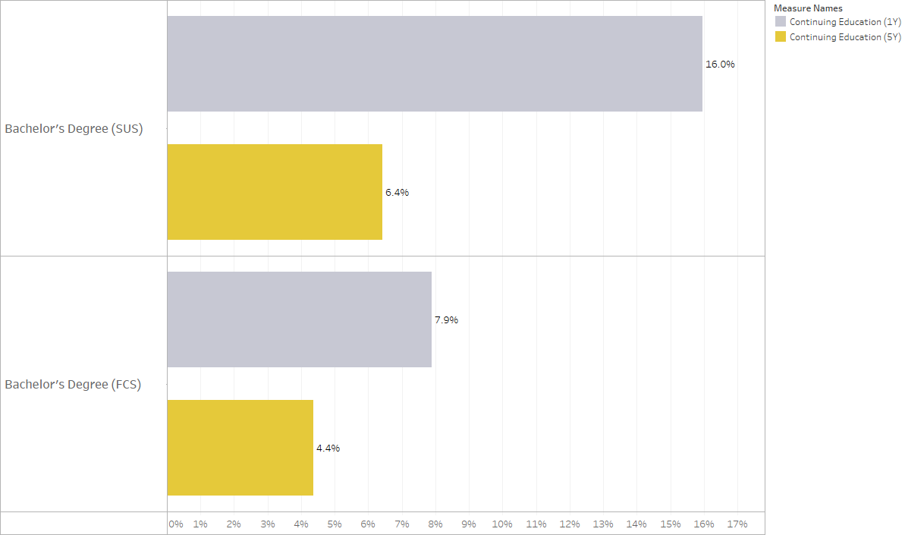

Master’s and Specialist Degrees
The master's degree is a one- or two-year postgraduate degree that is typically 30 to 45 credit hours beyond the bachelor's level. Master’s degree graduates are expected to possess advanced knowledge in a specialized body of theoretical and applied topics, higher order skills in analysis, critical evaluation or professional application, and the ability to solve complex problems and think rigorously and independently. Within Florida’s public postsecondary framework, master's degrees are only awarded by SUS institutions.
The specialist degree is above the master’s degree but below the doctoral degree and is a one or two-year degree typically 30 to 36 credit hours beyond the master's level. The specialist degree focuses on subjects related to K-12 education, such as educational leadership, curriculum and instruction, counseling, educational psychology and administration. Within Florida’s public postsecondary educational system, specialist degrees are only awarded by SUS institutions.
Public higher education institutions in Florida awarded 92,221 master’s degrees from 2017-18 through 2021-22, which was 8% of all degrees/certificates issued in that timeframe. As seen in Table 18, approximately 78% of these graduates were found within employment data one year after completion. During the five-year period, Florida’s universities awarded 1,248 specialist degrees (approximately 0.1% of all degrees/certifications issued across the five cohort years).

Table 18. Employment Outcomes of Graduates with Master’s/Specialist Degrees
Name | Total Graduates | Median First-Year Earnings | Percentage Found in Employment Data After One Year | Median Fifth-Year Earnings | Percentage Found in Employment Data After Five Years
Master's Degree (SUS) | 92,221 | $61,667 | 78% | $84,408 | 80%
Specialist Degree | 1,248 | $63,000 | 85% | $77,600 | 86%

What Students Study
Table 19 shows the first- and fifth-year outcomes for graduates of the most popular master’s degrees. Business Administration and Management was the most popular program. Among the most popular programs, there was a wide-range of first-year earnings from $47,325 (Social Work) to $101,644 (Computer and Information Sciences).
Among all master’s programs, median earnings had a range of more than $21,000 for Musicology and Ethnomusicology to more than $217,000 for Dental Clinical Sciences. Eight programs had earnings more than $100,000 in the first year after graduation.
Table 19. First- and Fifth-Year Employment Outcomes for Graduates of 10 Most Popular Master’s Degrees
Program | Total Graduates | Median First-Year Earnings | Percentage Found in Employment Data After One Year | Median Fifth-Year Earnings | Percentage Found in Employment Data After Five Years
Business Administration and Management, General | 11,643 | $77,648 | 85% | $112,262 | 85%
Accounting | 3,471 | $63,768 | 90% | $99,344 | 90%
Educational Leadership and Administration, General | 2,882 | $56,668 | 93% | $71,908 | 94%
Clinical/Medical Social Work | 2,710 | $47,325 | 86% | $61,560 | 75%
Registered Nursing/Registered Nurse | 2,693 | $88,656 | 90% | $112,291 | 85%
Business/Commerce, General | 2,449 | $73,920 | 87% | $99,242 | 85%
Public Health, General | 2,345 | $53,668 | 73% | $74,667 | 72%
Computer and Information Sciences, General | 1,977 | $101,644 | 77% | $173,419 | 87%
Curriculum and Instruction | 1,914 | $53,622 | 86% | $63,396 | 81%
Social Work | 1,837 | $48,508 | 86% | $60,418 | 79%

Specialist degrees are offered in 12 programs. Employment outcomes for the five-most popular are shown in Table 20. Eight of these programs have first-year earnings data available from 2017-18 through 2021-22. Among those eight programs, the median first-year earnings ranged from $40,736 for Marriage and Family Therapy/Counseling to $73,144 for Educational Leadership and Administration.
Table 20. First- and Fifth-Year Employment Outcomes for Graduates with Specialist Degrees, by Program
Program | Total Graduates | Median First-Year Earnings | Percentage Found in Employment Data After One Year | Median Fifth-Year Earnings | Percentage Found in Employment Data After Five Years
Curriculum and Instruction | 468 | $68,180 | 84% | $89,560 | 86%
Counselor Education/School Counseling and Guidance Services | 252 | $55,752 | 84% | $64,188 | 82%
Educational Leadership and Administration, General | 207 | $73,144 | 96% | $83,240 | 88%
School Psychology | 124 | $61,272 | 95% | $65,886 | 100%
Mental Health Counseling/Counselor | 107 | $41,444 | 73% | $61,370 | 70%

Doctorate Degrees
The doctorate degree is the highest degree awarded in the education system and is also the least frequently awarded. During the five-year period covered by this report, 25,000 plus graduates (2.3%) received some form of doctorate degree out of more than 1.1 million graduates from all three postsecondary education systems.
The doctorate degree can be grouped into three types: law, medical and non-medical. Some doctorate degrees are considered “professional” degrees in that they prepare students for professional careers in fields such as law or medicine. Other doctorate degrees prepare students for academic teaching and/or conducting research. These categories are further defined as follows:
Doctorate (Law) | Law school is where students obtain a professional education in law after first obtaining an undergraduate degree. This typically entails a three-year course of study. Several degrees are categorized within law, which include juris doctor (JD), the Master of Laws (LLM) and the Doctor of Juridical Science (JSD or SJD). Law schools in the United States confer the JD degree, which is a professional doctorate, the highest degree necessary to practice law in the United States and the final degree obtained by most practitioners in the field.
Doctorate (Medical) | The doctorate in a medical-related field (e.g., MD, DVM, DDM, PharmD) typically consists of four years of medical education. These doctorate programs prepare students to become professional physicians, pharmacists, physical therapists, dentists or veterinarians.
Doctorate (Non-Medical) | The non-medical doctorate (i.e., PhD, DrPH, EdD, DPT, etc.) is an advanced degree that typically requires 72 credit hours of advanced study beyond the bachelor’s level, or 54 hours beyond the master's level. Even though this group is labeled non-medical, there are several health-related degrees included within this grouping such as physical therapy/therapist, nursing practice, nursing science and epidemiology, along with many other non-health related degrees. The non-medical related doctorates prepare students for practitioner engagement, academic teaching and/or conducting rigorous research.

Doctorate Degree (Law) Outcomes
Four universities within the Florida public postsecondary educational system offer law degrees. Among them, as shown in Table 21, the median first-year earnings were $61,918 and nearly doubled after the fifth year to $109,220. More than 3,900 graduates were awarded law degrees from 2017-18 through 2021-22.

Doctorate Degree (Medical) Outcomes
Seven universities within the Florida public postsecondary educational system offer medical doctorate degrees (i.e., Medicine, Veterinary Medicine, Dentistry and Pharmacy). These medical fields produced 7,200 combined graduates from 2017-18 through 2021-22. Median first-year earnings for these degrees ranged from $59,524 for Medicine to $117,716 for Dentistry. Fifth-year earnings ranged from $99,375 for Medicine to $191,336 for Dentistry.

Doctorate Degree (Non-Medical) Outcomes
Within the Florida public postsecondary educational system, 10 universities offer doctorate degrees. Non-medical doctorates are offered in many different programs as compared to law and medical doctorates. As a result, there is a wider variation in earnings outcomes. There were nearly 160 non-medical doctoral degree programs from 2017-18 through 2021-22. The range of median first-year salaries was $42,164 on the low end for Music Theory and Composition to $176,016 for Nurse Anesthetist on the high end. Nurse Anesthetist graduates also had the highest number of graduates found within employment data after one year (94%). 17 different programs had median first-year earnings of more than $100,000.
Table 21. First- and Fifth-Year Employment Outcomes for Graduates with Doctorate Degrees
Name | Total Graduates | Median First-Year Earnings | Percentage Found in Employment Data After One Year | Median Fifth-Year Earnings | Percentage Found in Employment Data After Five Years
Doctorate Degree (Non-Medical) | 14,693 | $79,996 | 78% | $102,217 | 77%
Law | 3,903 | $61,918 | 78% | $109,220 | 83%
Medicine | 3,546 | $59,524 | 88% | $99,375 | 86%
Pharmacy | 2,649 | $77,628 | 80% | $130,916 | 87%
Veterinary Medicine | 558 | $85,603 | 90% | $125,892 | 87%
Dentistry | 447 | $117,716 | 76% | $191,336 | 92%

What Students Study
Table 22 shows the top 10 doctoral programs by popularity along with median first-year earnings. Tremendous variability exists between the different programs regarding first-year earnings. Among the most popular programs, median first-year earnings had a large range from $69,141 for Physics to $154,392 for Business Administration and Management. There also is a large range in the percentage of graduates found within employment records, ranging from 67% for Psychology to 90% for Nursing.
Among all non-medical doctoral programs, the percent of graduates found within employment ranges from 40% for Materials Science to 95% for Speech Communication and Rhetoric.
Table 22. First- and Fifth-Year Employment Outcomes for Graduates of the 10 Most Popular Non-Medical Doctorate Degrees
Program | Total Graduates | Median First-Year Earnings | Percentage Found in Employment Data After One Year | Median Fifth-Year Earnings | Percentage Found in Employment Data After Five Years
Nursing Practice | 1,888 | $112,364 | 90% | $126,616 | 88%
Physical Therapy/Therapist | 1,428 | $69,800 | 89% | $80,740 | 88%
Curriculum and Instruction | 645 | $77,117 | 78% | $91,728 | 81%
Chemistry, General | 570 | $75,096 | 68% | $108,905 | 71%
Electrical and Electronics Engineering | 496 | $118,181 | 71% | $150,982 | 73%
Educational Leadership and Administration, General | 463 | $78,364 | 89% | $97,310 | 84%
Psychology, General | 415 | $70,868 | 67% | $109,330 | 68%
Business Administration and Management, General | 407 | $154,392 | 82% | $207,950 | 84%
Physics, General | 329 | $69,141 | 70% | $122,960 | 66%
Mechanical Engineering | 329 | $88,785 | 70% | $120,021 | 75%

Student Loan Debt
In the fourth quarter of 2024, the National Student Loan Data System (NSLDS) reported $1.64 trillion in outstanding federal student loan debt. This is a 2.3% increase over the year from the end of 2023 ($1.6 trillion). At the end of 2019, federal student loan debt totaled $1.51 trillion – an increase of 8.6% from the previous five years.
Students who default on their loans might be without recourse. Loans cannot be discharged in bankruptcy and more young adults are saddled with outstanding credit card, automobile loan and student loan debts than ever before. With these burdens, monitoring student loan debt becomes a high priority.
In Florida, each institution in the FCS and SUS systems self-reports data about debt to the Office of Student Financial Assistance in the Florida Department of Education. Data contained in Table 23 represent the average federal student loan debt of all students that received federal loans in the 2021-22 academic year, including loans from Stafford, Perkins, Graduate PLUS, Parent PLUS and TEACH programs.
A total of $1.47 billion across 233,244 federal student loans was dispersed to FCS and SUS institutions in 2021-22. The statewide average was $6,286 per loanee.
There is a wide range in average loan amount due to many factors, which could include degree type, program length and student profile. The average loan for students in SUS institutions was $7,593 per student enrolled, and a ratio of 44.3 loans for every 100 students enrolled. For FCS institutions, the average loan amount for students was $3,340 and 19.5 loans for every 100 students. Student loan data were not available by the degree program but are instead averaged for each institution.

Average student loan debt per loanee reflects the total amount of student loans for each institutional system (FCS and SUS) in the 2021-22 academic year, divided by the number of federal student loans dispersed during the year.
Table 23. Summary of Federal Loan Data by Sector in the 2021-22 Academic Year
Data Type | FCS | SUS
Federal Loan Amounts Disbursed | $239,485,674 | $1,226,608,736
Number of Federal Loans | 71,694 | 161,550
Average Federal Loan Amount | $3,340 | $7,593
Fall Enrollment (2021-22) | 367,572 | 364,759
Ratio of Loans to Students Enrolled | 0.195 | 0.443

Public Assistance
Higher education is often viewed as one of the most productive forms of human capital investment that individuals and taxpayers make. Up to this point, this report has focused primarily on earnings that are associated with the completion of the most common degrees and certificates awarded in Florida. This section examines public assistance, which is an indicator of the financial well-being of graduates. Eligibility requirements for SNAP, for example, are limited to household incomes below 130% of the poverty line as of 2024. If a graduate is not in need of assistance, the more likely it is that they are financially viable.
In the current dataset, more than 60,000 graduates received public assistance one-year post-completion. The percentage of graduates who received public assistance ranged from nearly 15% for career certificates to less than 1% for master’s and some doctorate degrees. Just 0.3% of graduates from Medicine programs, for instance, received public assistance. Among programs with public assistance data, graduates of Home Health Aide career certificate programs had the highest percentage of students receiving assistance after one year (44.4% followed by 42.6% of Private Security Officer certificate graduates and 38.3% of Distribution and Logistics Management certificate graduates).
Figure 7 reports the percentage of graduates found in the wage database receiving public assistance by certificate/degree. Of note, the levels reported are not adjusted for differences in the skill level or income level of students who enrolled in these different programs. That is, these outcome measures are not adjusted for such factors known to affect student success.
Public assistance for graduates of certificate, diploma or apprenticeship programs ranged between 2.3% for graduates of Firefighter career certificate programs to 44.4% for graduates of Home Health Aide career certificate programs. Associate degree graduates had a smaller range receiving public assistance. On the low end, 1.2% of graduates of Emergency Medical Technology/Technician programs with an associate in science degrees received public assistance. On the high end, 23.9% of Community Health Services/Liaison/Counseling program graduates with associate in science degrees received assistance. Among bachelor’s programs, just 0.7% of Aerospace, Aeronautical and Astronautical/Space Engineering program graduates received public assistance on the low end, compared to 23% of Respiratory Care Therapy/Therapist program graduates on the high end. Just 1.5% of all master’s degrees and 0.4% of nonmedical doctorate degree graduates received public assistance one year after graduation.
Figure 7. Percentage of Graduates Receiving Public Assistance One Year After Certificate/Degree Completion
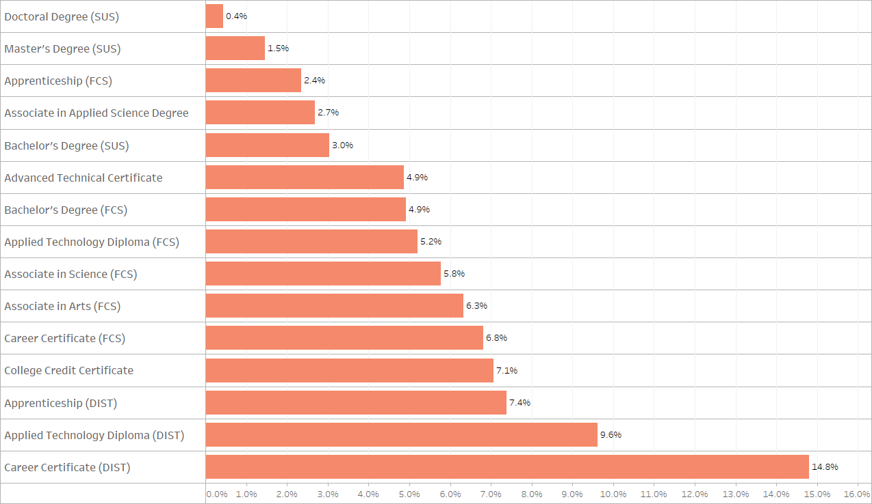

Labor Market Information: Which Jobs Are In Demand?
Although this report primarily focuses on the first- and fifth-year earnings of graduates for academic years 2017-18 through 2021-22, the earnings that graduates command are not only a function of the programs from which they graduate but also of the strength of the labor market into which they enter. The following subsections provide information about the demand for jobs, including information on the fastest-growing industries and occupations forecast through 2032. This section also provides information on the top 20 jobs statewide that require a postsecondary credential. Information in this section supplements the earnings data presented throughout this report to help individuals anticipate where the demand for workers may be strongest across Florida in the coming years.

Industry Growth
Long-term employment projections by industry and occupation are important indicators of labor demand. Table 24 and Table 25 show the top 20 industries with the fastest projected growth and the top 20 industries projected to gain the most jobs through 2032.
Table 24 below displays the fastest growing industries in Florida by 2032. Table 25 displays the industries gaining the most jobs between now and 2032. Professional and Technical Services are projected to gain 93,903 additional jobs by 2032, followed by Ambulatory Health Care Services (+70,264) and Administrative and Support Services (+68,674). There are 14 total industries projected to gain 10,000+ additional jobs by 2032.

Table 24. Forecast of Fastest Growing Industries in Florida, 2024-2032
Rank | Industry | Growth  (2024 to 2032) | Percent Growth  (2024 to 2032)
1 | Building Material and Garden Supply Stores | 20,930 | 20.8%
2 | Warehousing and Storage | 18,282 | 18.7%
3 | Wood Product Manufacturing | 2,476 | 16.1%
4 | Publishing Industries | 5,910 | 13.9%
5 | Furniture and Related Product Mfg | 1,882 | 13.7%
6 | Truck Transportation | 9,493 | 13.7%
7 | Couriers and Messengers | 9,191 | 13.5%
8 | Professional and Technical Services | 93,903 | 12.4%
9 | Furniture, Home Furnishings, Electronics and Appliance Retailers | 7,961 | 11.9%
10 | Ambulatory Health Care Services | 70,264 | 11.5%
11 | Telecommunications | 5,171 | 11.2%
12 | Administrative and Support Services | 68,674 | 9.6%
13 | Nonmetallic Mineral Product Manufacturing | 2,504 | 9.6%
14 | Real Estate | 16,331 | 9.5%
15 | Miscellaneous Manufacturing | 3,527 | 9.5%
16 | Educational Services | 19,950 | 9.1%
17 | ISPs, Search Portals and Data Processing | 2,493 | 8.3%
18 | Amusement, Gambling and Recreation Industry | 17,213 | 8.1%
19 | Internet Publishing and Broadcasting | 1,335 | 7.9%
20 | Insurance Carriers and Related Activities | 17,054 | 7.7%
*This table includes industries with a minimum of 10,000 jobs in 2024.
Source: FloridaJobs.org/economic-data/employment-projections.

Table 25. Forecast of Industries Gaining the Most Jobs in Florida, 2024-2032
Rank | Industry | Percent Growth  (2024 to 2032) | Growth  (2024 to 2032)
1 | Professional and Technical Services | 12.4% | 93,903
2 | Ambulatory Health Care Services | 11.5% | 70,264
3 | Administrative and Support Services | 9.6% | 68,674
4 | Food Services and Drinking Places | 7.1% | 62,187
5 | Specialty Trade Contractors | 5.5% | 23,976
6 | Building Material & Garden Supply Stores | 20.8% | 20,930
7 | Educational Services | 9.1% | 19,950
8 | Warehousing and Storage | 18.7% | 18,282
9 | Amusement, Gambling and Recreation Industry | 8.1% | 17,213
10 | Insurance Carriers & Related Activities | 7.7% | 17,054
11 | Real Estate | 9.5% | 16,331
12 | Local Government | 2.2% | 15,829
13 | Accommodation | 6.3% | 12,151
14 | Motor Vehicle and Parts Dealers | 6.8% | 11,194
15 | Truck Transportation | 13.7% | 9,493
16 | Couriers and Messengers | 13.5% | 9,191
17 | Furniture, Home Furnishings, Electronics and Appliance Retailers | 11.9% | 7,961
18 | Personal and Laundry Services | 7.2% | 7,952
19 | Merchant Wholesalers, Nondurable Goods | 4.5% | 6,984
20 | Management of Companies and Enterprises | 4.6% | 6,229
Source: FloridaJobs.org/economic-data/employment-projections.

At least every three years, the Florida Department of Commerce updates its Target Industry Report. The Target Industry List identified in 2025 is comprised of those industries that drive growth, innovation and resilience across Florida’s economy. Table 26 below displays the expected job growth for each of these industries through 2028.

Table 26. Forecast of Target Industries Job Growth in Florida, 2024-2028
Target Industry | Percent Growth  (2024 to 2028) | Growth  (2024 to 2028)
Cross-cutting Target Industries
Corporate Headquarters | 9% | 11,892
Logistics | 6% | 42,832
Manufacturing | 6% | 25,158
Research and Development | 13% | 3,353
Sector-specific Target Industries
Aerospace and Aviation | 10% | 14,314
AgTech | 12% | 39,128
Energy Security | 8% | 11,930
Financial Services | 8% | 112,934
Information Technology | 11% | 34,611
Life Sciences | 8% | 81,117
Maritime | 6% | 2,947
Military and Defense | 11% | 33,281
Source: 2025 Target Industry Report.

Among occupations related to Target Industries, the following jobs are projected to have the fastest growth by 2032: Podiatrists (+18.6%), Chiropractors (+17.1%), Optometrists (+17.0%), Veterinary Assistants and Laboratory Animal Caretakers (+16.7%), Veterinary Technologists and Technicians (+16.4%), Survey Researchers (+15.5%), Veterinarians (+15.0%), Physical Therapist Aides (+13.2%), Orthotists and Prosthetists (+12.9%), and Electro-Mechanical Technicians (+11.8%).

Other key occupational growth is expected from Atmospheric and Space Scientists (+11.7%), Statistical Assistants (+10.2%) and Computer Hardware Engineers (+10.0%). The occupation with the largest growth projected by 2032 is General and Operations Managers with 12,517 additional jobs. Medical Assistants is the occupation with the largest anticipated growth in Life Sciences by 2032 (+5,827).

Occupational Growth
In addition to identifying which industries are growing, it is also important to consider growth in occupations. As seen in Figure 8 below, occupational groups requiring some level of education beyond “some college, no degree” are all projected to grow faster than the baseline growth rate across all occupations between 2025 and 2033. Jobs requiring a master’s degree are projected to growth the fastest, followed by jobs requiring a postsecondary nondegree award. Occupations requiring a doctoral or professional degree have the highest average hourly wage of any group ($56.24), followed by bachelor’s degrees ($40.74) and master’s degrees ($40.56). Jobs that require a postsecondary nondegree award earn, on average, $5.34 more than jobs that only require a high school diploma or equivalent, while those requiring associate’s degrees earn $11.97 more than the high school or equivalent category.
Figure 8. Projected Growth in Labor Demand by Level of Education, 2025-2033

Table 27 below shows the occupations requiring a postsecondary education beyond a high school diploma with employment more than 4,000 that are projected to grow the fastest through 2033. Among the top 20 fastest-growing occupations meeting these criteria, six require a postsecondary nondegree award, two require an associate degree, eight require a bachelor’s degree and the remaining four require a master’s, doctorate or professional-level degree.

Table 27. Forecast of the Fastest Growing Occupations in Florida, 2025-2033
Rank | Standard Occupation Classification (SOC) Title | 2025-2033 Projected Growth |  | Median Wage (2024) | Education
Rank | Standard Occupation Classification (SOC) Title | Growth | Percent Growth | Median Wage (2024) | Education
1 | Nurse Practitioners | 11,139 | 46.1% | $61.70 | Master's degree
2 | Physician Assistants | 2,913 | 29.4% | $61.50 | Master's degree
3 | Medical and Health Services Managers | 10,488 | 25.6% | $61.82 | Bachelor's degree
4 | Veterinary Technologists and Technicians | 2,723 | 24.6% | $20.79 | Associate's degree
5 | Veterinarians | 1,404 | 23.4% | $68.29 | Doctoral or professional degree
6 | Operations Research Analysts | 1,735 | 21.8% | $40.59 | Bachelor's degree
7 | Logisticians | 2,620 | 21.4% | $36.54 | Bachelor's degree
8 | Financial Examiners | 982 | 20.3% | $39.60 | Bachelor's degree
9 | Computer and Information Systems Managers | 5,482 | 19.5% | $82.23 | Bachelor's degree
10 | Physical Therapist Assistants | 1,948 | 19.3% | $32.92 | Associate's degree
11 | Medical Assistants | 10,925 | 18.4% | $20.66 | Postsecondary nondegree award
12 | Financial Managers | 8,179 | 18.0% | $80.69 | Bachelor's degree
13 | Industrial Engineers | 2,440 | 17.5% | $54.82 | Bachelor's degree
14 | Dental Assistants | 4,636 | 17.3% | $22.44 | Postsecondary nondegree award
15 | Speech-Language Pathologists | 1,494 | 17.3% | $44.60 | Master's degree
16 | Psychiatric Technicians | 2,238 | 17.1% | $21.08 | Postsecondary nondegree award
17 | Ophthalmic Medical Technicians | 1,114 | 15.8% | $21.49 | Postsecondary nondegree award
18 | Massage Therapists | 2,223 | 15.3% | $24.33 | Postsecondary nondegree award
19 | Truck Drivers, Heavy and Tractor-Trailer | 16,693 | 15.3% | $26.13 | Postsecondary nondegree award
20 | Mechanical Engineers | 1,420 | 15.3% | $48.98 | Bachelor's degree
Source: FloridaJobs.org/economic-data/employment-projections.

Appendix

Graduate Cohort Classes 2017–18 Through 2021–22
The cohort represented in this report includes graduates during their first year after graduation from public postsecondary education institutions for each academic year 2017-18 through 2021-22. Florida’s public postsecondary education institutions include the SUS, FCS and DTCs. The data for this cohort reflects employment and earnings outcomes, election to continue their education, student loan debt and level of public assistance.

Key Concepts
Median first- and fifth-year earnings and subsequent education are key concepts related to the employment outcomes used throughout this report. These rates are combined for the first year after graduation across graduates from the 2017-18, 2018-19, 2019-20, 2020-21 and 2021-22 academic years. The fifth-year rates reported only include the 2017-18 academic class. Only earnings records that met or exceeded the annualized Florida minimum wage threshold for the applicable year are included in median wage calculations. This approach ensures students, parents and other stakeholders have access to outcomes for most programs. Due to confidentiality and validity restrictions, a minimum of 10 individuals with outcomes are required to include results for each program in this report. Results are suppressed when fewer graduates appear within any specific program.
The median is the middle score in a distribution, and the first-year earnings of graduates reported here reflect the median over five-years. Annualized calendar year fourth quarter (October–December) earnings of graduates for each year were arranged by institution from lowest to highest, and the middle value was selected for each institution and from a combined, sorted statewide list. Wage data from the State Wage Interchange System (SWIS) is the underlying source of the employment and earnings data. Some information, such as wages for sole proprietorships and federal employees, may not be included in the data.
Unemployment Insurance (UI) wage records provide information about employment and earnings only. These records do not provide data about the occupations in which graduates are employed. Therefore, it is not possible to know whether graduates are employed in their fields of study or in other fields.
The education enrollment data reflect a five-year average. The number of students enrolled in higher education in the academic year following graduation for academic years 2017-18 through 2021-22 was summed and divided by the total number of graduates across the five years. Data on graduates continuing their education out-of-state is not included in this report.
Outcome data related to graduates as well as education enrollment are provided by the Florida Education and Training Placement Information Program (FETPIP). FETPIP, located in the Florida Department of Education, is a data collection and consumer reporting system established by Florida law to provide follow-up data on former students and program participants who have graduated, exited or completed a public education or training program in Florida.

Definitions
Area of Study | The area (or field) of study code and program as referred in the Classification of Instructional Program (CIP). The CIP was developed and is maintained by the U.S. Department of Education’s National Center for Education Statistics (NCES). According to NCES, “CIP provides a taxonomic scheme that supports the accurate tracking and reporting of fields of study and program completions activity. CIP was originally developed by the U.S. Department of Education’s National Center for Education Statistics (NCES) in 1980, with revisions in 1985, 1990, 2000 and 2010.” For more information about CIP codes, visit the NCES website.
Employment Records | Employment data obtained from UI wage records, as provided by SWIS data for the 2017-18 through 2021-22 cohort years.
Found Enrolled in Subsequent Education Percentage | The number of graduates who were enrolled at a DTC, FCS or SUS institution in the fall and spring semesters following graduation or completion of an educational program, divided by the total number of graduates.
Median First-Year Earnings | The middle score in a distribution of annualized calendar year fourth quarter (October-December) earnings of graduates one year after graduation. These earnings were arranged by institution from lowest to highest, and the middle value was selected for each institution from a combined, sorted statewide list.
Median Fifth-Year Earnings | The median of the annualized calendar year fourth quarter (October-December) earnings of graduates of the 2017-18 academic year five years after graduation.
Minimum Wage Threshold | A threshold was applied to all earnings data based on the annualized Florida minimum wage in the applicable year. Earnings data that fell below this threshold were not included in median earnings calculations. The thresholds applied to the five graduating classes described in this report are shown in Table 28.
Table 28. Minimum Wage Threshold by Academic Year
Year | Min. Wage | Min. Wage Threshold  4th Quarter | Min. Wage Threshold  Annualized
2017–2018 | $8.25 | $4,290 | $17,160
2018–2019 | $8.46 | $4,399 | $17,597
2019–2020 | $8.56 | $4,451 | $17,805
2020–2021 | $8.65 | $4,498 | $17,992
2021–2022 | $10.00 | $5,200 | $20,800
2022–2023 | $11.00 | $5,720 | $22,880
2023–2024 | $12.00 | $6,240 | $24,960
2024–2025 | $13.00 | $6,760 | $27,040
Number of Graduates | The total number of students who completed or graduated from a program.
Public Assistance Percentage | The number of graduates who received public assistance from the Temporary Assistance for Needy Families (TANF) program or the Supplemental Nutrition Assistance Program (SNAP) during the fourth quarter of the year, divided by the total number of graduates.
Student Loan Debt | The total amount of federal student loans for 2021-22 at each Florida public postsecondary FCS and SUS educational institution, divided by the number of students who received a federal student loan at those institutions during the 2021-22 academic year.
Total Found Employed Percentage | The number of graduates with earnings, divided by the total number of graduates.

Data Disclosure
The data provided for the cohorts represented in this report include only graduates with valid Social Security numbers. Earnings are representative of graduates who met the full-time threshold. The full-time threshold equals the hourly minimum wage, multiplied by 40 hours per week, multiplied by 13 weeks. Earnings and public assistance data reflect the fourth quarter of the year (October-December). Earnings are annualized by multiplying by four (which is equal to one year’s earnings). Records are deduplicated between years so that each student is represented only once per year.
Data on student loan debt are self-reported by each public educational institution at the institution level. The data reflect the average student loan debt of all students (i.e., those who were enrolled and those who graduated) at that Florida public postsecondary educational institution in 2021-22, divided by the number of students who were enrolled. The data include federal student loans from Stafford, Perkins, Graduate PLUS, Parent PLUS and TEACH programs.



.

Prepared by the Florida Department of Commerce, Bureau of Workforce Statistics and Economic Research

The SWIS program is a system whereby states can share aggregate employment and wage outcomes with other states. It includes wage data from all 50 US states, Puerto Rico and the District of Columbia. More information can be found at DOL.gov/agencies/eta/performance/swis.
Excludes occupations that require only a high school diploma or GED.
This classification and information about all other fields of study used in this report are defined by the U.S. Department of Education’s Classification of Instructional Programs (CIP) Code.
District Technical Colleges (DTC) do not report debt information, so average debt for students at these institutions are not reported here.
Excludes Chipola College and North Florida College where data were not reported.
For purposes of this report, public assistance includes a unique count of graduates who received support or services from the Temporary Assistance for Needy Families (TANF) program and/or the Supplemental Nutrition Assistance Program (SNAP).
SNAP household eligibility: https://www.fns.usda.gov/snap/recipient/eligibility.
Includes the top 20 ranked occupations, excluding those that only require a high school diploma or GED.
NCES.ed.gov/ipeds/cipcode/Default.aspx?y=55.
WRIS2/SWIS data were excluded for the 2015–2016 cohort year.

