**From:** Leslie Judd   
**Sent:** Friday, November 02, 2018 3:02 PM  
**To:** Leslie Judd <[ljudd@irsc.edu](mailto:ljudd@irsc.edu)>  
**Subject:** Clark News for the week ending 11/2

**Celebration and Appreciation**

Huge thanks to **Ecological Associates, Inc.** for wrapping up the funding needed for Mrs. Bartow’s Anatomy students to head to the bone museum this spring to supplement what they are learning.

Thanks to the **Cloudt family** for the incredible staff breakfast!

**Sam McCreary earned the rank of Eagle Scout** this week.  He is a member of Troop 822 in Palm City. What an honor to achieve this designation!

A huge shout out to **Bianca Grosso** for her selection as the **2018 mARTies Award winner for the Student Literary category** (pictured next to Mr. E below).  Congratulations also to our other school nominees:  Mr. Escandon, Trinity Hamilton, Amy Nicholas (2nd from right), David Bayless (far right), Katelyn Smith, Jake Coker, Weston Frates, and Michael Parmiter.  So very proud of this terrific & talented group of nominees!

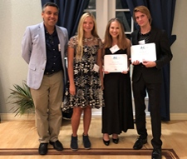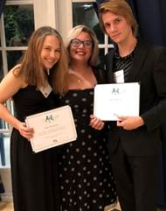

Shout out to **Hannah Evans** as she has won 2 high point saddles, was AQHA Youth Champion this year and her recent win was the Youth Class at RSTPA finals.  Wow!

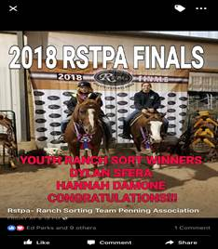

Congratulations to **Karen Gedamke** on being the recipient of the Character Counts! award for the pillar of respect. 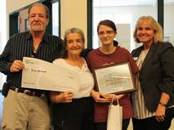

**Announcements and Happenings**

Clark student, Aidan Ferguson, is leading a **Thanksgiving basket project for Elev8Hope families** in need. For every 5 items donated, you will receive 1 service hour. Donations can be dropped off to the front office starting TUESDAY (make sure your name is on your bag so you get credit!). TURN IN BY TUESDAY!  Our goal is to assemble at least 12 full baskets to assist local families from all of the schools. Here is the list of items needed for each basket: stuffing mix, gravy, cranberry sauce, canned corn/ green beans/sweet potatoes, boxed dessert (cake mix/frosting/brownies), and roasting pans. Publix gift cards to be used towards turkeys are also accepted. Thanks to all who have donated thus far!

**Trick or Treat for UNICEF** battle of the block 2 classes ended this week with a grand total of **$298.97** being raised to help children worldwide in need. The top 3 classes were: Mr. Escandon’s with an average of $3.92 donated per student, Mrs. Gribble’s with average of $$3.75 and Mrs. Mercado’s with an average of $3.66. Thank you to all for your generosity!

At an assembly Monday, junior **Chris Wood** (left below) leads a discussion **with local Veterans about their experiences to help everyone truly remember why Veterans Day exists.** We greatly appreciate **Mallory Johnson’s mom and grandfather** for sharing their valuable insights and lessons with a room full of attentive students. We also want to recognize Chris for leading this initiative and selecting the Semper Fi Fund as a charity to fundraise for this month at Clark. Read more about the fund and see the PowerPoint from Monday that shares the many Clark “family” members who are Veterans or active in our military.

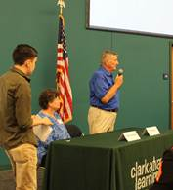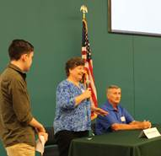

**Students had a great time last week celebrating Character Counts! and Red Ribbon Week.** Congratulations to Mr. Escandon’s class that won the door decorating contest for the theme “Character Counts at Clark!” Runners Up: Mrs. Mercado’s College Algebra class and Mrs. Bartow’s Ecology class. Students also enjoyed wearing different clothing to represent various pillars and getting candy and ice cream, too!

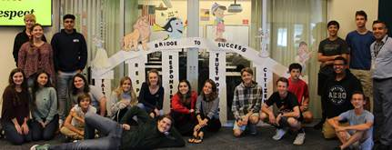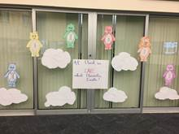  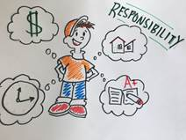 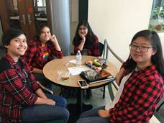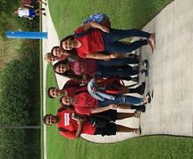

**Clark's Winter Dance is coming up soon on Friday, November 16th, from 6:30pm - 10:30pm!**  This year's theme is "Dancing Through the Decades", so wear attire from your favorite dancing decade and come join the fun!  Tickets will be on sale starting next week for only $12; then, the price will increase to $15 for the week of November 12th.

We have 4 students (**Julia Chavez, Ashlee Farias, Julia Howe, and Ashley Elkins**) in Alice in Wonderland at SFHS Nov. 8-10. Show your support by attending a performance. Tickets can be bought ahead showtix4u.com

**Mrs. Kohuth extends a huge thank you** to our Clark students and parents for the special treats and sweet sentiments shared throughout October for National Principals Month.  “I am humbled and blessed to be the Proud Principal of Clark Advanced Learning Center, at which we strive everyday collectively to make a safe, KIND, pleasant, professional, positive, and FUN school for learning and growing academically and socially.  When students or parents let me know that what is done at Clark influences their lives even beyond school, my heart is even warmer!”

**Several Career Workshops at IRSC** for November (see attached). Everyone invited!

Don’t forget to **set your clocks back** for the time change Sunday! Yes, it is still in effect for this year!



**Mr. Judd’s classes have been participating in a “Genius Hour”** this semester and have taken learning into their own hands! One student, **Sarah Bell**, learned about the water issues and created this petition as part of her project. She explains, we had 10 minutes at the end of each class to work on something creative that was not for another class. I chose to learn about the water mismanagement problem we have in Florida. I chose to use my research to set up an online petition supporting the Comprehensive Everglades Restoration Plan (CERP). The goal is to reach 1,000 signatures, at which point I will begin sending the petition to policymakers. <https://www.change.org/p/ljudd-irsc-edu-dirty-water-stinks-support-the-comprehensive-everglades-restoration-plan-cerp-79d43401-86fa-4eaa-97b4-f71b51b41c49>

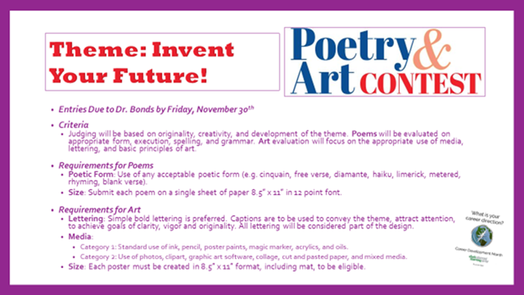

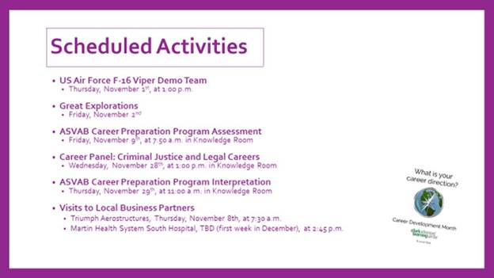

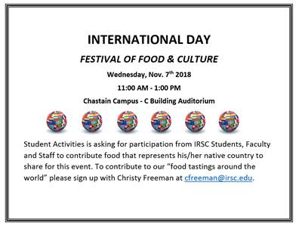

**Leslie Judd, LMHC, Ed.S.**

Assistant Director

Clark Advanced Learning Center

772.419.5758

**“Work to Your Potential, Not Your Quota” –Grant Cardone**