**Celebration and Appreciation**

Treasure Coast **Rowing** Club competed in Augusta, GA at the head of the south last weekend. Congrats to **Mackenzie Abbott, Lucas Guaglardi, and Jordyn Golden** on earning silver and 4 team medals overall.

Congratulations to the following Clark seniors nominated for the **Joe Kordick Youth Character Award** for consistently displaying the 6 pillars of character counts! **Courtney Carroll, Mitchnida Clervil, Allison Falco, Trinity Hamilton, Vianca Martinez, Alyssa Mastriano, Shane Maxson, Tyler Melton, Amy Nicholas, and Devon Shpiruk, & Katelyn Smith**

Clark **Interact and Keystone Club members made a $150 donation to Elev8Hope** this week using the funds raised during change for change. Thanks to all who collected and donated!

Thanks to our **blood donors who helped save almost 30 lives** through the gift of life! Next drive will be inn January and our goal is to double the amount of blood collected!

Huge thanks to the families who donated towards our **Thanksgiving food baskets**. Senior, **Aidan Ferguson**, took on this project from sorting, to assembling, to delivering… we love our students with such generous hearts!

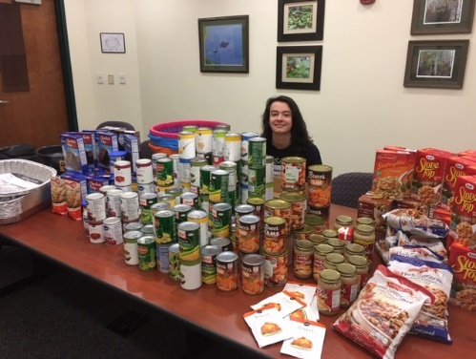 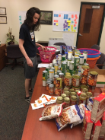

Clark employees had a great time celebrating our Education Foundation of Martin County’s **Teacher of the Year** candidate last Friday night. It was a magical event all about the amazing, Harry Potter loving, science genius, **Mrs. Bartow**!

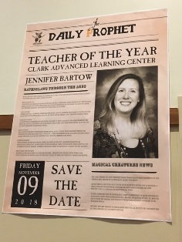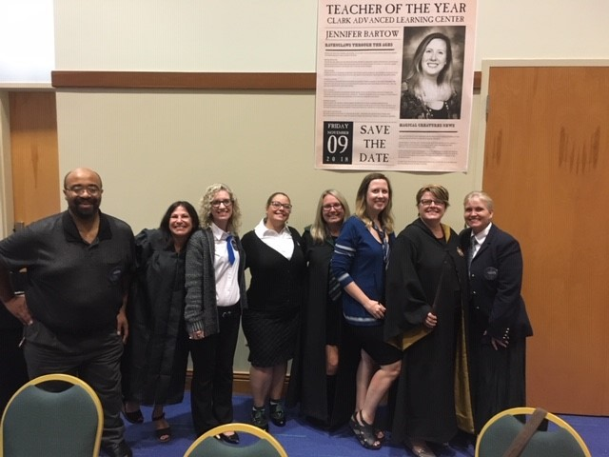

**General News**

**Reminder that Clark and IRSC are open for business as usual Monday and Tuesday.** However, the will be no buses. Lunch will be available. **Please email** [**sschubar@irsc.edu**](mailto:sschubar@irsc.edu) **if you will be buying/getting lunch** Monday and/or Tuesday so she can order enough.

There are two days coming up that **students can try rowing for free** to see if they are interested in joining Rowing Club. [www.treasurecoastrowingclub.com](http://www.treasurecoastrowingclub.com/)  Sat. Dec 1 Junior Learn To Row Day 7:30 - 11 am 6 - 12th grade FREE

Sat, Jan 5 Spring Learn To Row Day 7:30 - 11 am 6 - 12th grade FREE

Sat. Jan 7 – 11 Learn to Row Week Try rowing to see if you'd like to join for the Spring Middle School: M/W/F 4:30 - 6:45 pm High School: M/T/R/F 3:45 - 6:45 pm Treasure Coast Rowing Club 771 SW 28th St, Palm City

**Articles of Interest for Parents**

The Teen Vaping Trend – What Parents Need to Know

<https://drugfree.org/parent-blog/the-teen-vaping-trend-what-parents-need-to-know/>

|  |  |
| --- | --- |
| [https://www.bing.com/th?id=OVP.uBJcaBQd4nJXDLejBpXtXAEqDX&pid=Api](https://drugfree.org/parent-blog/the-teen-vaping-trend-what-parents-need-to-know/) | [The Teen Vaping Trend – What Parents Need to Know - Where Families Find Answers on Substance Use | Partnership for Drug-Free Kids](https://drugfree.org/parent-blog/the-teen-vaping-trend-what-parents-need-to-know/)  drugfree.org  Vaping or JUULing is often shrugged off as 'safer than cigarettes.' But parents should be aware of the risks of teen vaping, and what they can do about it. |

What Parents Should Know About Teen Depression: Look for these signs and be proactive in addressing the mood disorder

<https://health.usnews.com/wellness/for-parents/articles/2017-02-01/what-parents-should-know-about-teen-depression>

|  |  |
| --- | --- |
| [https://www.usnews.com/dims4/USNEWS/4a2f3a0/2147483647/thumbnail/970x647/quality/85/?url=http%3A%2F%2Fmedia.beam.usnews.com%2F42%2F02c8718f0fc424cd94f090c1d1eefa%2F43986WideModern_Depression_130703.jpg](https://health.usnews.com/wellness/for-parents/articles/2017-02-01/what-parents-should-know-about-teen-depression) | [What Parents Should Know About Teen Depression | For Parents | US News - US News Health](https://health.usnews.com/wellness/for-parents/articles/2017-02-01/what-parents-should-know-about-teen-depression)  health.usnews.com  Parents shouldn't just dismiss possible signs of depression, such as teens being extremely argumentative and withdrawing from family and friends, as normal adolescent behavior. |

Respectfully,

Leslie Judd, LMHC, Ed.S.

Assistant Director

Clark Advanced Learning Center

“One child, one teacher, one book, one pen can change the world.” -- Malala Yousafzai