How to Print at School
These instructions will assist you in using the Universal Printer to print at school.
1. Pull up what you want to print or what your teacher is asking you to print.
2. Click File in the top left corner then click print.
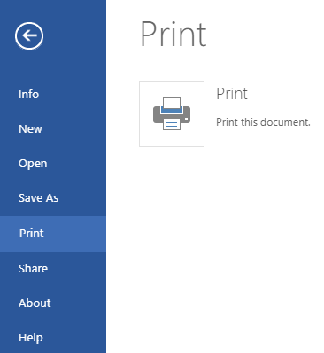
3. Once the option screen pops up, click Change… button.
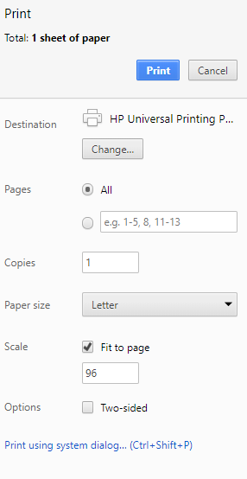
4. This will open up a list of printers, click the one that says “HP Universal Printing PCL 6.”
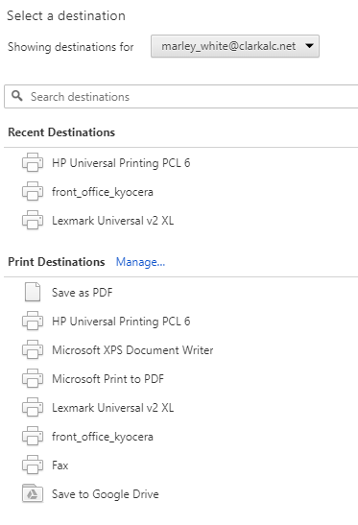

5. Then all the way at the bottom click “Print using system dialog…”
6. Make sure “HP Universal Printing PCL 6” is highlighted in blue and the click “preference” on the right side of the little pop up window.
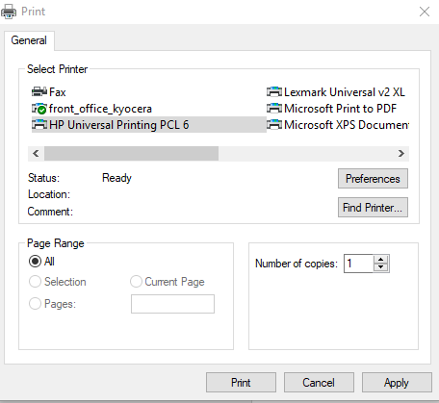
Click preferences
Make sure this is highlighted in blue or gray
7. Then select “Enter a Printer Address”.
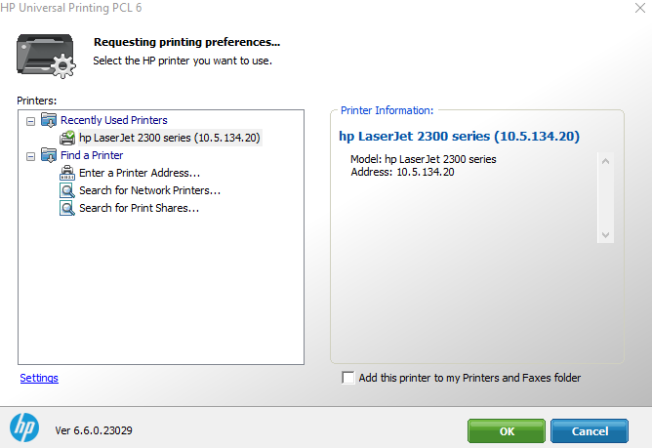
Click this and it will open a little pop up window
8. When that little box pops up, type in the printer IP address, most likely your teacher will have this for you.
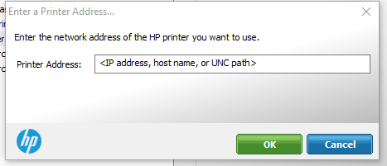
Type in the IP address of the printer here.
Ex. 10.5.134.20
9. Once you have typed in this address, click OK.
Click OK when you have typed in the address.
10. Make sure the correct printer and IP address in on the right side of the screen under Printer Information.
Printer name and IP address should be displayed here, check to make sure it is correct.
11. Then click OK, the computer should show a little looking screen.
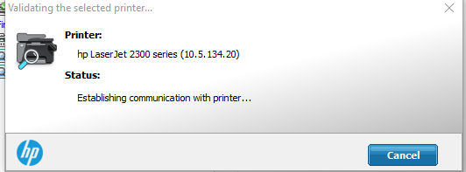
This is what the looking screen looks like.
12. Then a pop up window displaying printing preferences will come up, just click OK
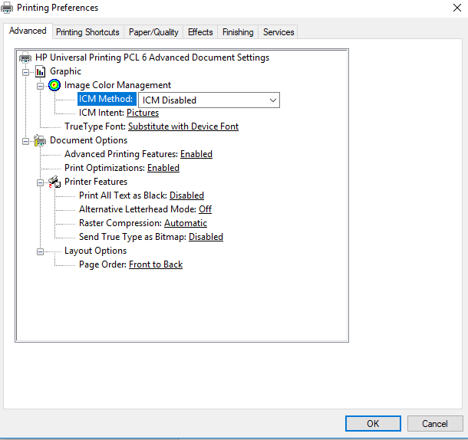
Printing preference screen looks like this, just click OK
13. Then press print and you should be good to go.

