Help support **NHS and Relay for Life by stopping by the Car Wash tomorrow** at Advanced Auto Parts in Stuart on US1 from 9-1 am tomorrow.

The Clark Interact Club has made it easy to give to **Collect for Cures – fundraiser for Leukemia and Lymphoma Society** running through March 8, 2018: Collect for Cures boxes in classrooms and at Front Desk – **just $3 per Clark student and we meet our $750 goal!** and/or Online donations <http://events.lls.org/pages/pb/Clark-Advanced-Learning-Center-2018> and/or by way of Blood Drop purchase -- $1 from any Interact Club member.

Come eat and proceeds will be donated to LLS at Chipotle in Stuart near intersection of US 1 with Monterey (**2181 SE Federal Highway)** THIS **Monday, March 5th** between **5:00pm** and **9:00pm**. Show flyer to have an automatic donation made to our cause! Chipotle Flyer:

<http://socialportal.chipotle.com/fundraiser/social/portal/flyer/iDcPGp4eILfvYZVETv69rhPri1U0S91IrR8kMGj3a6XefzvFtSd3sR9CJ44bA3wPEj3OAHGmxNy22HqUP2t455Bzc7ZgXVT6NAPWfCor4tdlHoSinOfGxRpVkk7fGhEQ/148392-flyer.pdf>

Huge thanks to all of the students and parents who were able to come by our **Inaugural Wellness Fair** today. There was a lot of good feedback from students and participants and we look forward to welcoming the event again next school year. Raffle prize winners were: **Michael Parmiter, Gabe King, Janessa Tomas, and Daisy Brant**! Come see Ms. Judd for your gift card!

Congrats to our **National Speech and Debate Qualifiers, Noah Reilly and Zain Jarrar** (1st alternate)! Impressive work in the tournament last weekend!

Huge thanks to the **Pollis family** for an incredible staff breakfast this week!

If you know of a female student who would like to attend prom but **can’t afford a dress for the event**, the 4C’s organization (Caring Children Clothing Children) will be receiving prom dresses from Dillard’s.  The week of March 12th (Spring Break), they will be open for students to pick out a dress for free. This program is open to any student in MCSD’s Families in Transition program, but it is also open to migrant students or students that qualify for free/reduced lunch. See Ms. Jones for more information and a referral.

10th graders are breathing a sigh of relief after completing the 2 hour required **Writing portion of the FSA today**. MANY thanks for being on time and giving great effort! Those who were sick will make it up at 7:50 Monday in room 210.

Congrats to the winners from Clark of a recent art contest (kinetic pointillism): 1st- **Theresa Legein; 2nd- Ana Paes; 3rd- Lillian Dobbs**

Congratulations to **Caroline Nolan** who received the Joe Kordick Youth Character Award and $1000 Wednesday evening for consistently living a life of good character!

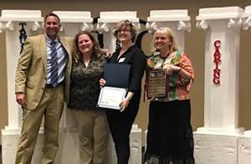

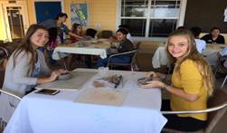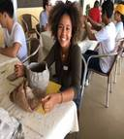

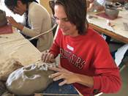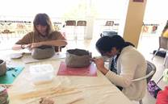

Mrs. Gribble’s students enjoyed learning how to hand build ceramic sculptures in a workshop led by local artist Gail Kosowski at Plein-Air ArtsDay sponsored by the Arts Council of Martin County. (photos above)



**Celebrations of acts of kindness and character this week include:**

Caring: **Hannah Evans** for being concerned about a fellow student's class performance and for being willing to help that student to complete his assignment.

Responsibility: **Bill Loutus** for being a diligent and inquisitive student. Billy is an example to other students in my English 3 class, for he completes assignments on time, asks questions, and stays on top of his classwork.

Thank you **Dillon Hansen and Alex Perez** for consistently showing up to help tutor in Geometry.

**Shane Maxson** for helping Mr. Judd when he needed it.

**Leslie Judd, LMHC, Ed.S.**

Assistant Director

Clark Advanced Learning Center

772.419.5758

**At Clark, we Fully Believe In student success!**

