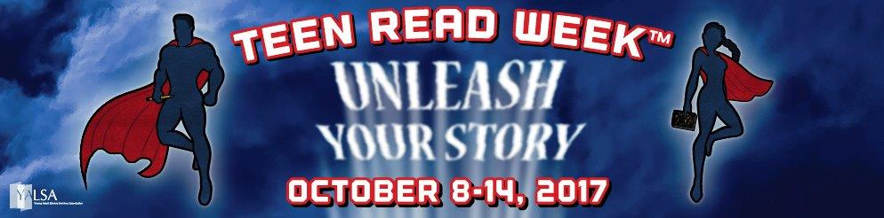

**Totally**

**Teen**





*For information, contact Donna Michalak at (772) 463-2805 or dmichala@martin.fl.us*

*All Homework Helper programs and workshops are sponsored by The Library Foundation of Martin County, Inc.*

* Teen Amnesty for Overdue Fees. Visit one of our branches and

speak to a librarian to have your fines forgiven.

* Selfie contest! Pose with your favorite book or create a

Bookface photo.

* #MCLSTeenRead2017

**You’ll be entered for a chance to**

**win a $25.00 Amazon gift card**.

3 winners chosen October 16.

**Unique programs at each branch. Connect with us.**

* Come and watch the movie, *Everything, Everything*
* The Hunt for Your Adventure
* Pick your favorite book
* Create a button
* Scavenger Hunt
* Makerspace
* Unscramble the Book Title
* Or come see the movie,

*Before I Fall*

**October 8th – 14th, 2017**