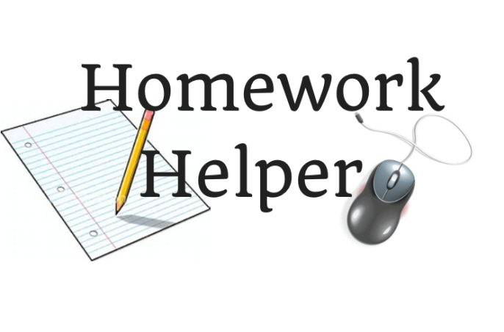

***Get face-to-face tutoring with the Martin County Library System Homework Helper program. Homework Helper volunteers are available by appointment.***



All Homework Helper programs and workshops sponsored by The Library Foundation of Martin County, Inc.

**To schedule an appointment, call Becky Scheelk at**

**(772) 463-2805 or email** [**rscheelk@martin.fl.us**](mailto:rscheelk@martin.fl.us)

Students have access to library resources and online tools to make learning and completing homework successful. Open to students

grades K-12.

***Homework Helper also offers workshops focusing on popular school topics. Check our calendar under ‘teens’ for the latest programs.***

**NEED HOMEWORK HELP TONIGHT?**

Get live one-to-one homework help *online* daily from 2:00pm to 11:00pm. Live chat option is now available!

Access tutor.com through our

library website at <https://www.martin.fl.us/Libraries>

Click on the Kids, Teens, Parents link. Use your library card number to sign-in.

