**Textbook Distribution for Summer A** (only) will begin Tuesday, May 8 – Thursday May 10.  Please come to the office & see Ms. Schubart or Ms. Judd for checkout.

**Laptop returns** begin May 14th. No students are allowed to keep the school laptop beyond May 24.

If you’ve finished scheduling next year’s classes & would like to **volunteer at the front desk** in the fall, please sign up at the front desk.  It’s a great way to gain valuable work experience and earn service hours as well.

Congrats to Clark senior and JBHS swimmer, **Jaxson Rees** who was recognized by the Florida Athletic Coaches Association (FACA) as one of 28 Players of the Year from the Treasure Coast!

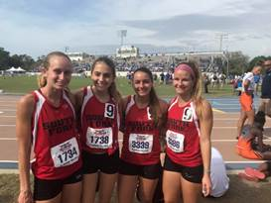

Congrats to Clark students on the SFHS track team (Far left- **Hannah Martin, next to her, Sophia Ward, Far right- Julia Surgeont**) This relay team broke 2 SFHS relay records at track at the Regional meet at SFHS (4 x 400m by 3 secs) and 2 weeks ago at UF track meet (Distance medley by 4 secs)! Julia will be competing at States in her first year!

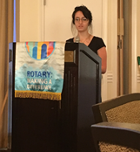

**Gianna Califano** shared her appreciation for the Stuart-Sunrise Rotary Scholarship she received this week.

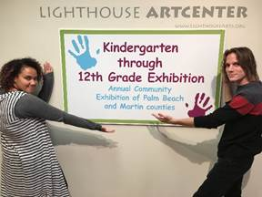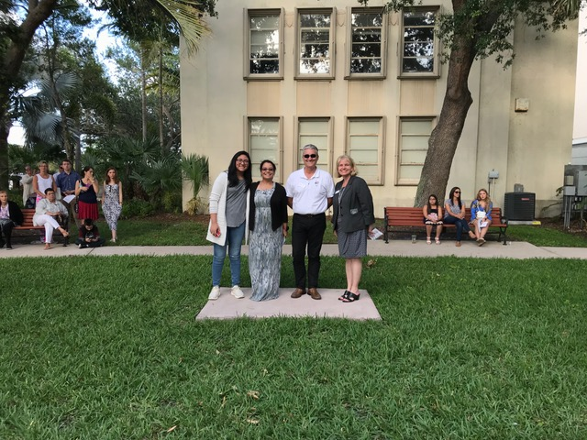

Art students made a great showing in the annual **Marvin S Cone Juried Art Show** (Crystal Aguilar pictured on left) and **The Lighthouse Center for the Arts** student exhibition this week (Thalia Miles and David Bayless on right).  Congrats to David whose sculpture won for 11th grade in the Lighthouse Show! Also, great talent is on display all month for both of these and the following students are involved: Cone- **Theresa Legein, Mya Desimone, David Bayless, Crystal Aguilar, Brooklyn Holland, and Amy Nicholas**. Lighthouse- **Theresa Legein, David Bayless, Titan Davis, Thalia Miles, and Crystal Aguilar.**

A big thank you to **Josh Berg, Mackenzie Armstrong, Kya Klaasen, Shelby Smith, and Lillian Dobbs** for helping Dr. Bonds by greeting Business Partners who came to hear Intern Capstone Presentations on Tuesday and escorting them to the Dome.  This was SUCH a big help!

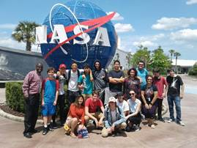

**The Computer Club** (and guests) enjoyed a fun and educational trip organized by Mr. Minnis last week to Kennedy Space Center!

This morning we had the pleasure of thanking our “**Everyday** **Superheroes**” at our annual Volunteer, Community, and Business Partner breakfast.  Enjoy just a couple of the fun pictures taken by our own Mrs. Gribble!

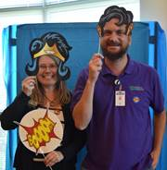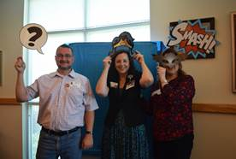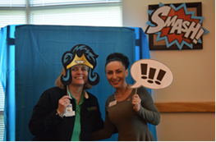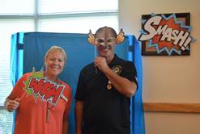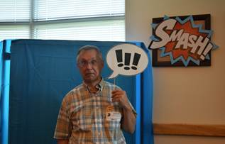

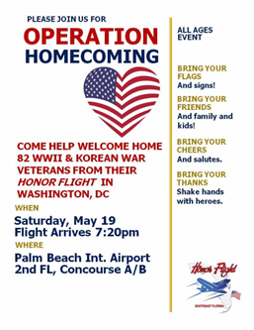

See above for a valuable experience open to all students and families. For more information or questions about Operation Homecoming, please call 1-855-FLYAVET (855-359-2838) or email us at [info@honorflightsefl.org](mailto:info@honorflightsefl.org)

**Leslie Judd, LMHC, Ed.S.**

Assistant Director

Clark Advanced Learning Center

772.419.5758

**At Clark, we Fully Believe In student success!**

