**We are so excited to once again be recognized on the U.S News & World Report’s Best High School List.**  Here is the statement Mrs. Kohuth shared with the media in case you missed seeing it. “Student success is the number one priority at Indian River State College, and this commitment extends to our students at the Clark Advanced Learning Center. Inclusion on the U.S News & World Report’s Best High School List is a reflection of the diligent work of our students, educators, and support staff at the Clark in a collective pursuit of excellence. We are exceptionally proud of our students and their continued success. The Clark team of educators and support staff are exceptionally proud of our students for their continued success. Our master instructors work diligently to foster a love of learning coupled with confidence and competence in the coursework by each of our students. Exceptional student performance is the result of outstanding teaching, a supportive learning environment, and the persistence of our students who intensely focus on their academic goals.

**Congratulations to the 94 seniors who will be graduating tomorrow at 10:00 am!** They have accomplished GREAT things and are on their way to even greater accomplishments in college, careers, and the military!

**Summer camps** at Keiser. See attached.

**Clark’s Interact Club is collecting the following supplies for LAHIA.**  Donations can be brought into Clark thru June 6. - Men's shorts (longer shorts) under 42 waist; Men's denim and long work pants (Wrangler's, Lee, Dockers, Dickies, etc.); Lightweight windbreakers; Socks - white, black, or gray; Work shoes/boots (sizes 8-12); Under-T-shirts - round and v-necks (dark colors); ALWAYS can use T-shirts for outer wear (They have plenty of button-down and polo shirts); Ladies underwear, bras, socks, capris (dark colors) – all sizes.

Save the Date! **The 2018-2019 UF Open House** will be held on Saturday, July 28, 2018. High school student’s grades 9-12 are invited to attend. Attendees will learn more about UF majors, financial aid, admissions requirements and the Student Self-Reported Academic Record. The program is designed to provide a comprehensive overview of the services and resources available to students, a glimpse of campus life, and access to academic guidance and opportunities for college planning.

Two Clark students were doing great things last week! **John Klingensmith** is pictured (far left) at the Court of Honor last Saturday where his Eagle Award was conferred on him. He made the awesome benches that our seniors left their mark on this year. **Tyler Melton** (far right) volunteered as a guardian for Korean veteran, Mr. Holtzman, for the Southeast Florida Honor Flight day trip to Washington D.C. on Saturday, May 19th

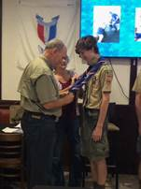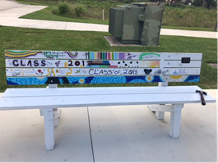 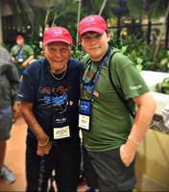

**Clark summer hours:** Mon- Thurs from 7:00 am – 5:30 pm.

We’ll be back Tuesday to collect those overdue textbooks and laptops or your money to replace!

**Leslie Judd, LMHC, Ed.S.**

Assistant Director

Clark Advanced Learning Center

772.419.5758

**At Clark, we Fully Believe In student success!**

