**From:** Leslie Judd   
**Sent:** Friday, April 06, 2018 2:03 PM  
**To:** Leslie Judd <[ljudd@irsc.edu](mailto:ljudd@irsc.edu)>  
**Subject:** Clark weekly news for the week ending 4/6

**Thanks to all of the parents, students, and employees for your efforts and time before and during our SACS re-accreditation visit this week.** Pending approval of the AdvancED Board, we will be re-accredited!  We will get a final report in about 45 days, but the 4 visiting team members shared that it was evident that our culture is reflective of our beliefs, we offer unique opportunities, students and staff have high expectations, and our employees are making a difference in the lives of our students.  Proud to be a Clark crane!

The Juniorettes of the Women’s Club are holding a car wash and bake sale fundraiser **this Saturday and could use a few student volunteers**.  The contact is Naureen Haider ([naureenhaider@gmail.com](mailto:naureenhaider@gmail.com)), 772-341-2943.  The car wash will be at the front entrance driveway of the Woman’s Club on East Ocean Blvd.  They will sell coffee and baked goods that members of that club will bring.  Flyer attached.

As we wrap up this school year, please pay attention to these **attendance expectations from our handbook** that were reviewed at orientation AND in your classes the first days:

Page 9: “Accumulation of six (6) absences in one Clark class may result in academic penalties and/or disciplinary action up to, and including, non-reenrollment at Clark. (Absences with a doctor’s note and/or for school sponsored activities are exempt from this consequence).

Page 11 “Requests for excused absences for high-school courses for family travel or vacation must be submitted in writing a minimum of two weeks in advance for Executive Director’s approval. Failure to obtain prior approval may result in unexcused absence(s).”

**Prom tickets** will be on sale through 3 pm this Wednesday. All guest forms are due at that time also. Don’t miss out on that super fun night or the fun daily events leading up to the Midnight Lights 2018 Prom!

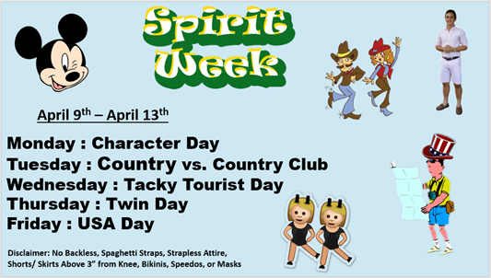

Please plan to join us for the **Parents as Partners (PaP) meeting in the Knowledge Room on Thursday, April 19, at 6 pm** for the monthly overview of school happenings and volunteer updates.  The topic will be preparation for college, with a focus on information from Ms. Jones for our underclassmen including ongoing career & college exploration and college visits.  Suggested timelines and resources will be shared!  Looking forward to many parents and students attending the April PaP meeting at Clark.

**Career Fair at IRSC Chastain Campus**, Friday April 13, 9:00am-1:00pm! Attached is a flyer with a link for pre-registration, and all of the details.

**Seniors attending Grad Bash**--- check your IRSC email. Permission slip is attached to it and there is a MANDATORY meeting at 12:15 in the KR on Tuesday, April 17.

**Student and Staff Recognition**

**Congratulations to Claire Arcement and Theresa Legein** for each earning FIRST place for their respective art work in IRSC’s 18th Annual Digital Media Student Exhibition on Friday! Your talent and creativity is amazing!!!!!!

Brian Barral was honored as a member the IRSC All Academic Team… way to go! (3rd from left)

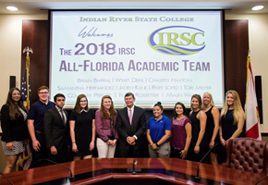

Employee Crane Awards for March:

From a parent: I would like to nominate **Mrs. Mercado**. Not sure what other teachers are doing this but I thought it was awesome to instill an incentive program to leave their phones on her desk during class. Thanks for teaching them to let go of their dependency on their phones.

And… **Ms. Schubart** probably doesn’t get recognized much but as a volunteer I see her heart for the kids and her drive to create a wonderful impression as you come into the school. She is a gift and I pray she is recognized for being such.

YIKES! I have not been very responsible and forgot to add several shout outs to the weekly news! Here are the most recent as shared on the morning announcements:

**David Bayless** for picking up litter outside on the Clark Campus (responsibility, citizenship)

**Abigail** for staying late and helping Mrs. Schubart by taking an extra front desk shift (caring, trustworthiness)

**Adriana Perea** for always helping me with my homework (caring)

**Clara Boyer** for always being nice to fellow students and helping out (caring, respect)

**Hannah Martin** for bringing a great attitude no matter the stress of the situation (fairness, respect)

**Adileni** for always helping me and being a kind and patient friend (caring)

**Lillian Dobbs** for always being friendly (caring)

**Ruby Selkinez** for always being there when you need a friend (trustworthy)

**AJ** for gathering a team to post “CURES” from purchased blood drops for LLS support (citizenship, responsibility)

**Karen Gedamke** for helping Mrs. Kohuth carry LOTS of items from her car (caring)

**Kyle** for always offering to help me study (caring)

**Titan** for always being a great friend and making people smile (caring)

**Isabella** for brightening others’ days and being a good friend (caring)

**Mollie** for being such a kind and caring soul. She is always willing to forgive and give others a second chance, even if they don’t deserve it (fairness, caring)

**Leslie Judd, LMHC, Ed.S.**

Assistant Director

Clark Advanced Learning Center

772.419.5758

**At Clark, we Fully Believe In student success!**

