Who wants to cook the night before Easter or the day after???? Make dinner a selfless act by joining us for a fundraiser to support Clark UNICEF Club. Come in to the **Chipotle** at 2181 SE Federal Highway in Stuart on **Saturday, March 31st between 5:00pm and 9:00pm.** Bring in this flyer (attached), show it on your smartphone or tell the cashier you’re supporting the cause to make sure that 50% of the proceeds will be donated to Clark Advanced Learning Center UNICEF Club.

Then, grab **Five Guys on Monday from 3:00-9:00** and support the Interact Club!

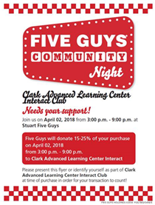

**If you have every contemplated becoming a writer,** you will want to attend the English, Communications, and Modern Language Department’s annual Writer’s Day on Saturday, April 7th.  Whether you write for fun or as part of your job, this is an amazing opportunity to enhance your writing and learn from published authors.   Everyone is welcome, so please pass the word on this amazing event!! Please see the attached flyer for more information.

**Young Musicians Spotlight** (see attached)

**Cash for College is coming** (see attached)

**Art Contest!** <http://files.constantcontact.com/ccc86944601/a5543dd9-eab1-4933-8108-045cb4540b92.pdf>

**Scheduling for SUMMER courses began today.**  If you wish to take IRSC classes this summer, please sign up for an appointment with Ms. Jones in the binder outside of her office.

**Prom tickets** will be sold until Wednesday, April 11th.  Tickets are $45 for Clark students and $55 for non-Clark students.  Prom will be held on Friday, April 13th at 7pm at the Kane Center.  Tickets will be available for purchase from Ms. Jones or during lunches starting Wednesday.

**Voting for this year’s prom king and queen has begun**.  ALL students are eligible to vote.  Please submit your nominations no later than Tuesday, April 3rd in the box in the front office.

**Study Abroad** trip deadline for lowest payment is next Wednesday. Join Mr. Judd, Ms. Judd and possibly some other staff as we explore Venice, Salzburg, and Munich during Spring Break 2019. Email [wjudd@irsc.edu](mailto:wjudd@irsc.edu) for info.

**Student News and Gratitude!**

Go see 3 Clark students performing in **Annie at SFHS** this weekend… **Jennifer Nicholas, Echo Tantillo, and Julia Howe**!

**Camila Guillen was recognized this week for the pillar of fairness** and was joined by family members. Way to go!

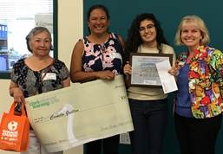

The SFHS Varsity sailing team was invited to participate in the SAISA district championships held in Jacksonville last weekend. The top 16 teams from across the SE United States and Caribbean competed over two days with the top three teams being invited to attend the High School National Championships to be held in May in Houston, Texas. After two hard days of sailing **SFHS won the SAISA district championships**! The Varsity B team with Clark students, **Kate Herter (left) and Griffin Pollis** (right), finished third overall.  They made it really count when it was needed and came from behind in the last race to win the championship by 1 point!

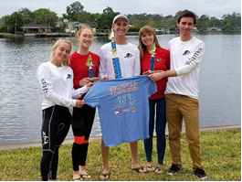

Congrats to the 14 students inducted to Mu Alpha Theta (Math Honor Society) this week (9 pictured below).

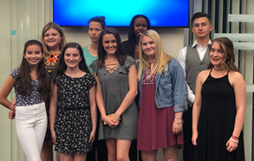

**Thanks to the Keyes family** for sponsoring staff breakfast this week and **the Saxton family** for helping to restock our soft tissues for these spring colds!

**Leslie Judd, LMHC, Ed.S.**

Assistant Director

Clark Advanced Learning Center

772.419.5758

**At Clark, we Fully Believe In student success!**

