**Parking passes are REQUIRED** to park in the lot behind Clark. Make sure yours is displayed properly and that you have one. If you are borrowing a car for a day, you need to see Mrs. Schubart so she can notify security. Students are NEVER to park in visitor or employee spaces.

**Clark Annual Satisfaction Surveys were e-mailed** last night and today to all parents and students. There are only 10 questions and we ask that you please complete these before next Friday (parents and each grade level have their own survey link). Your input on what is working and what can be improved is valuable! Please make use of the comment boxes if you have areas for improvement to note or extra special praise for what we are doing right.

**Want to return next year to Clark?** Pink slips have been passed out throughout the week to all 10th and 11th grade students to complete and return in order to save your space for next school year. If you did not receive one, stop by the front office to pick it up. These need to be returned before February 9.

Can you believe it is almost time for **interim grades**? If you do not have grades currently that you feel good about, talk to your teachers or Ms. Jones and see how you can achieve what you want. Tutoring is available…just ask!

**Several contests to win money**, recognition, and scholarships were included in last Friday’s email newsletter (<http://www.clarkadvancedlearningcenter.org/p/215/weekly-newsletter#.WnTMMa6nGUl>) Log into your IRSC email daily so you don’t miss out! If you cannot access your email, see Mr. McCrory near the career café as he is happy to help with your technology needs.

Beauty and The Beast at **Family Movie Night** In The Park.  See attached flyer for details

**Gatortales newsletter** attached. It has information for seniors but also for underclassmen, pertaining to summer programs.

Attached is **High school Years newsletter** for February with a segment on RESPECT as well as short tidbits on writing of nonfiction, career exploration, and danger zones for young drivers.

**SHOUT OUTS OF APPRECIATION FOR KINDNESS AND CHARACTER!**

**Robbie Riggs** is being recognized for responsibility and kindness. He happily helped Ms. Jones and Ms. Judd to get some boxes and things put away upstairs yesterday. It lightened the load for both of them!

**Camila Guillen, Tony Pisano, Jamar Brown (both nights), Micaela Pedro, Adriana Perea, Adeleni Morales-Zavala, Clara Boyer, Jimmy Peterson, Sydney Martinez, Isabella Jolly** all served as student ambassadors for our new student Info Sessions. Thanks for being leaders!

**Mallory Johnson** for being a true friend, putting a smile on everyone’s face and providing a ride to her classmate.

The four Clark seniors who were finalists for the Joe Kordick Youth Character award for consistently demonstrating all 6 pillars throughout their lifetime thus far: **Maggie Wright, Caroline Noolan, Camila Guillen, and Abigail Satchell.** A huge congrats to Caroline who was selected as this year’s recipient from Clark by a panel through the Character Counts! program at the United Way of Martin County

Staff breakfast was graciously provided by the **Yeary family** this week… Thanks!

**Mrs. Guillen, Kathy Peterson (both nights), Mrs. Mastriano, Mrs. Carroll, Mr. Martinez, Mrs. Legein** were amazing parent helpers for both new student Info Sessions this week. Thanks for helping and representing Clark!

Congrats to the South Fork Girls Varsity soccer team who won Districts last Friday.  They advance to Regionals on 2/6 at 7pm and the game is at South Fork.  Clark students on the team are **Leia Rausch, Julia Surgeont, Shannon Norton, and Abby Atwell.** Keep up the great effort lady bulldogs!

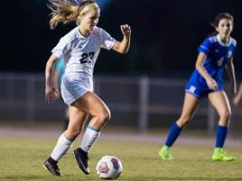   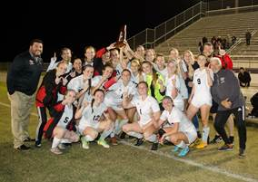

**Leslie Judd, LMHC, Ed.S.**

Assistant Director

Clark Advanced Learning Center

772.419.5758

**At Clark, we are “Building on Excellence”**

**Everyone. Everyday. Every way.**

