**Announcements**

**Photography contest** (see attached)

**Calendar** for next year is posted on our website.  Save the date for **mandatory** returning student and parent orientation on Tuesday, August 7 from 5:30-7:30 pm.

**State testing in officially done** for this school year at Clark! HUGE thanks to the students who ALL arrived on time and were seen giving their best effort on all of the testing.  We expect test scores to arrive around June 29 and will send a message when we have them.

Done with classes? **Return your textbooks and your laptop** when all classes are complete. NO laptops may be kept over the summer for any reason.

If you have **artwork from Mrs. Gribble’s class** (or even from Mr. Stiles last year), please come by and pick it up before the end of school next week.

**Thanks and Congrats!**

Congratulations to 14 of our seniors who represented Clark at the annual Pathfinders awards in West Palm Beach on Thursday night!  You make us proud with all you have accomplished! How exciting and well-deserved for **CAROLINE NOLAN to have placed FIRST for the category of SCIENCE!**

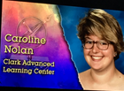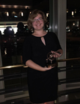

Huge thanks to the **Cantor and Golden families** for the incredibly yummy breakfasts the last couple of weeks!

Huge thank you to the many students and staff who attended the **Ice Cream Social** last week for new Clark students.  You make us proud when you share your enthusiasm for Clark!

Congrats to the most recent Clark grads of the **Martin Youth LEADERship program**! (L-R)  Jimmy Peterson, Ella Burgener, Daniel Ballinger, Mrs. Kohuth, Tyler Melton, Lily Orazi.  Applications for rising juniors are due next Friday to Mr. McCrory.

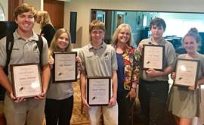

**Leslie Judd, LMHC, Ed.S.**

Assistant Director

Clark Advanced Learning Center

772.419.5758

**At Clark, we Fully Believe In student success!**

