**From:** Leslie Judd   
**Sent:** Friday, April 20, 2018 4:52 PM  
**To:** Leslie Judd <[ljudd@irsc.edu](mailto:ljudd@irsc.edu)>  
**Subject:** Clark updates for the week ending April 20

Great job to the **NHS Relay for Life team who raised over $4027** for the American Cancer Society this year!

**Prom 2018 was a success!** Mrs. Kohuth was sooooooo appreciative of the essential help after the prom as four Clark students (and two dates!) assisted with clean up and delivery of items back to Clark after the incredibly fun and well-attended event. A special THANKS to these six students who assisted us with transport beyond clean-up of The Kane: **Gwen, Jake, Brenna, Ben, Jimmy and Jordan**! Shoutouts, too, for Ms. Jones, Mrs. Bartow, Mrs. Gribble for ALL their hard work with preparations, plus Mrs. Mercado, Mr. Bicksler, Mr. Gribble, Dr. Bartow, Allison Cushman, Tim Edwards, Ms. Judd and Mrs. Kohuth as well as Mr. Omar Anez, Mr. Chris Carley, and Mr. Drav Durham for support and assistance before, during and/or after Prom 2018!!!

Thanks to those who have sent in donations or volunteered to help with **Teacher and Staff appreciation week!** There’s still time if it has slipped your mind ☺

**WaterFest** is tomorrow at Memorial Park in Stuart and Clark UNICEF club will be there will fun activities and raffles to raise awareness of the global water crisis, the mission of UNICEF USA and raise funds for UNICEF.  Stop by and see us between 9-1. Free fun for the whole family!

**FSA testing schedules** are posted in the front office windows. All 10th graders need to see where and which 2 days they are testing in a couple weeks. See Ms. Judd if there are issues with assigned times.

**Sailing fundraiser** Help support the Clark students on the SFHS team by eating at Anthony’s tomorrow night!

2343 SE Federal Hwy, Stuart Recently winning the District Championships, the team now is heading to Texas for the National Championships. 20% of dine-in and carry out sales will be donated, please tell your server you are dining to support the SFHS Sailing Team. Thank you.

Way to go Clark sophomore, **Shelby Smith**! Shelby went to Regional 8 gymnastics competition last weekend and qualified for JO Nationals for level 10 in Cincinnati, Ohio. She is in the top 56 in the nation for her age group. NCAA college coaches will be recruiting at this event. This is the highest level of competition until college.

**Some fun photos from Spirit Week last week! Thanks SGA for your hard work!**

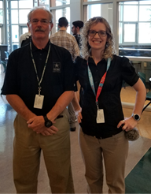Math Teachers on Twin Day!

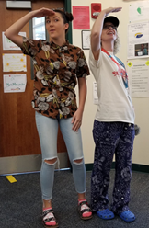Senior Erica Holmes and Mrs. Mercado on Tacky Tourist Day!

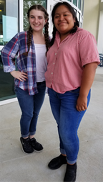Sophomores Gina Saxton and Liz Lucas-Pascual on Country vs Country Club Day!

Celebrations of kindness and character:

Parker Sherman for helping out at the last minute to cover the front desk.

Mrs. Rizzo for being our favorite sub! She comes at a moment’s notice and is always helpful

**Leslie Judd, LMHC, Ed.S.**

Assistant Director

Clark Advanced Learning Center

772.419.5758

**At Clark, we Fully Believe In student success!**

