**LOTS OF KUDOS TO OUR AMAZING STUDENTS THIS WEEK!**

Congrats to Clark sophomore, **Faith Olsen**, on winning 3rd place ($100)-in a recent contest sponsored by the Supervisor of Elections office. She will be recognized by the Board of County Commissioners next month!

Good luck this weekend to Clark rowers, **Mackenzie Abbott and Gabriella Galland**, as The Treasure Coast Junior Rowing Team will be traveling to Sarasota this Friday April 13 for the FSRA Sculling State Championships (4/13-4/15).

Huge thanks to the **Ginn family** for an amazing employee breakfast this week!

Congratulations to Clark senior **Caroline Nolan** for her selection as the 2018 Rising Star by Soroptimist of Stuart.  We are so very proud of **Jordan Poe and Jasmine Whitaker** for their nominations as well!

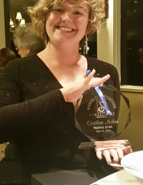  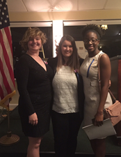

Congrats to senior **Maggie Wright** on her recognition today for the Daughters of the American Revolution Good Citizen Award!

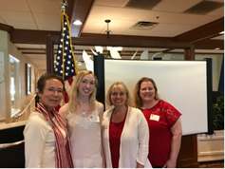

Four Clark students were recognized as inductees to the **Nu Iota Chapter of Phi Theta Kappa** on Monday afternoon at Main Campus in Fort Pierce. Congratulations to **Jessica Flannery, Alyssa Mastriano, Abbie Nauss** (pictured below), **and Ana Paes** for your scholarship, leadership, and service!

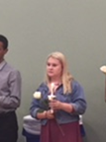

Please share with Clark in congratulating five of our seniors who were recognized at Main Campus in Fort Pierce on Thursday as part of the annual **College Awards Ceremony**.

**Brian Barral** was honored for his selection as a member of the All-Florida Academic Team.

**Andrew Potawsky** was presented with the Superlative Distinguished Scholar award for Arts, Humanities, and Design.

Brian and Andrew along with **Camila Guillen, Jordan Poe, and Maggie Wright** received recognition as 2017-18 IRSC Distinguished Scholars for their outstanding academic achievement and participation in extracurricular activities.

Student and employee submissions for random acts of kindness and character:

From Mrs. Gribble: Just wanted to recognize **Caroline Nolan, David Bayless, and Adriana Perea** for their assistance with the construction of the tree arch for prom.

**Clara Boyer** for always driving people home.

**Maggie Wright** for being a caring friend.

**Ismael Vilchiz** for helping out a student with homework assignments.

**Micah Todd** for always lending a helping hand.

Updates:

Clark NHS has raised around $3000 for the American Cancer Society and will be having fun while raising more money tomorrow night at Relay for Life.

Attached is the flyer for parents regarding the upcoming ALICE Parent Training Nights.

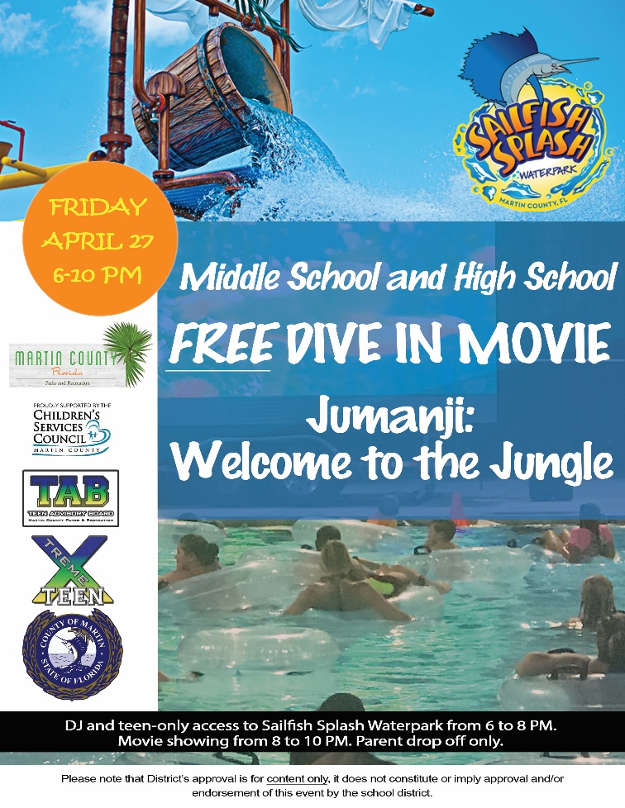

**Leslie Judd, LMHC, Ed.S.**

Assistant Director

Clark Advanced Learning Center

772.419.5758

**At Clark, we Fully Believe In student success!**

