**From:** Leslie Judd   
**Sent:** Friday, March 23, 2018 2:19 PM  
**To:** Leslie Judd <[ljudd@irsc.edu](mailto:ljudd@irsc.edu)>  
**Subject:** Clark news for the week ending 3/23

**The blood drive is next Wednesday, March 28 from 9:00-2:00** in the A parking lot. Donors receive 2 free movie tickets and you save lives. As seen, blood supplies are critical when tragedies like the Parkland shooting occur and for children and adults with cancer and other illnesses requiring transfusions to stay alive. Everyone over 16 is eligible to donate. Permission forms for 16 year olds are in the front office. Invite everyone you know to come save lives next Wednesday! Make an appt here: [www.oneblooddonor.org](http://www.oneblooddonor.org) sponsor code 9560

**The Coley Run in memory of Clark student, Coleman Merrill**, is being held April 7 to raise funds for a scholarship.  Details to participate here: <https://raceroster.com/events/2018/16775/coley-run>

**Report cards from Quarter 3 were mailed this week**. Any questions about grades, please contact the instructor or Ms. Jones. IRSC grades will not be available until May.

On Friday, March 30th, Clark and IRSC classes will meet as usual.  However, due to the Martin County School District schedule, we will have **no bus service** that day.  Bus riders will need to provide their own transportation to and from school. Clark will provide a **pizza lunch combo** for $2.50 or just pizza for $2.00. Free/reduced lunch will be honored. Sign up for pizza in the front office ASAP.

**Scheduling for SUMMER courses** will begin on Friday, March 30th.  If you wish to take IRSC classes this summer, please sign up for an appointment with Ms. Jones in the binder outside of her office.

**Prom tickets** go on sale this Wednesday, March 28th and will be sold until Wednesday, April 11th.  Tickets are $45 for Clark students and $55 for non-Clark students.  Prom will be held on Friday, April 13th at 7pm at the Kane Center.  Tickets will be available for purchase from Ms. Jones or during lunches starting Wednesday.

**Voting for this year’s prom king and queen** will begin on Wednesday.  ALL students are eligible to vote.  Please submit your nominations no later than Tuesday, April 3rd in the box in the front office.

**Video submissions for the event Stars Over Stuart** are being accepted (see attached):  Talent with a message for Martin County High School age youth as well as holding auditions dates at the 10th Street Center: 724 east 10th Street, Stuart, FL 34994.

**Clark Interact Club** is sponsoring burger, fries and shake night at Five Guys on Monday, April 2 from 3 to 9.  Five Guys will donate 15-25% of purchases accompanied by a flyer or mention of Clark Advanced Learning Center to our Club for service projects.   Please plan to stop by to support Interact! Five Guys Located in: Stuart Centre Address: 2185 SE Federal Hwy, Stuart, FL 34994  Five Guys Flyer: <http://ontrack.pgprint.com/storefrontDocumentDepot/D-fgbf-3EC3C571_D-fgbf-3EC3C571_00001.pdf>

**Florida Oceanographic Society offers youth (ages 15-18) volunteer opportunities** year round, but during the summer they add a volunteer internship program.  The internship incorporates education, research, advocacy and non-profit operations. It is an 8-week program that requires three half-day shifts/week commitment. Parts of the program are on a set schedule and the rest is flexible.  For students who do not/cannot make that type of a commitment, but are still passionate about coastal environments, we have opportunities for exhibit guides at our Coastal Center. This would require one half-day shift/week commitment. This is a very flexible schedule. More info here: <http://www.floridaocean.org/p/272/youth-opportunities#.Vub1bWDmq1s>

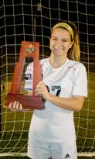**Julia Surgeont was awarded PLAYER OF THE YEAR** at South Fork High School for her soccer dominance and teamwork!

Thanks **Coker family** for staff breakfast this week!

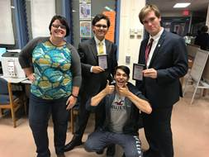

**Congrats Noah Reilly (right), Zain Jarrar (center) and Mason Johnson** (not pictured) for another weekend of great debate. Picture above includes advisor, Ms. H and alum/supporter, Nico.

**Congratulations and THANK YOU to Mr. Judd’s 3rd Block** class for contributing the most amount of money to Clark Interact Club’s recent fundraiser for Leukemia and Lymphoma Society!  Ice Cream was enjoyed by all!

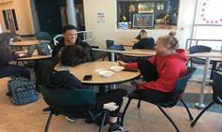  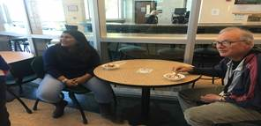

**Leslie Judd, LMHC, Ed.S.**

Assistant Director

Clark Advanced Learning Center

772.419.5758

**At Clark, we Fully Believe In student success!**

