First and foremost, I hope that each and every member of the Clark family was safe throughout the storm and you are beginning to return to a sense of normalcy. We are here for you! Please speak to Ms. Jones (tjones@irsc.edu) if your family has unmet meeds as she has a list of resources and can offer school based support to you/ your student.
Here are some updates from the past couple of weeks:
RESCHEDULED EVENTS:
Parent Volunteer Meet and Greet- Friday, Sept. 29 at 9:30 am
Senior Student and Parent Information Night- Thursday Sept 21 at 6:00 pm
Sophomore and Junior Parent Info Night remains Tuesday, Sept 19 at 6 pm.
Picture Day will be held on October 24. Seniors still need to get to the studio for their headshots. Email agribble@irsc.edu or jescando@irsc.edu with Senior picture questions.
Prom Committee will hold its first meeting on Sept. 28 in room 144.
OTHER INFO:
Due to this storm, the Hispanic Heritage Month submission deadline has been EXTENDED to 5:00 p.m. Eastern Saturday, September 30, 2017. Through the 2017 Hispanic Heritage Month contests, three students in grades 4-12 will earn a 4-Year Florida Prepaid College Scholarship and two K-3 students will earn cash prizes. http://www.floridahispanicheritage.com/
Debate and Interact Club are still selling awesome coupon books. Send $25 in for each book and questions can be directed to ahutches@irsc.edu or dkohuth@irsc.edu
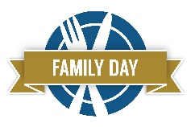 Please see attached information regarding Family Day, which will be celebrated on Monday, September 25, 2017.
Clark is participating in Students4H2O's Plastic Bag Initiative started by our very own alum, Adriana Mancini. This initiative is important because educating families and the youth in our community about the effects plastic bags have on our waterways. You can now bring in your soft plastics that are translucent, no black or dark-colored bags (meaning no lawn or hefty trash bags) to the collection bin near the front office. We are looking for volunteers who will take the collected bag to our assigned Publix about 1x per month. Email Ms. Judd if you would be willing ljudd@irsc.edu
Mu Alpha Theta (Clark’s Math Honor Society) is planning to sell SAT and ACT flashcards… Please complete this one question survey to let them know if you are interested or not https://www.surveymonkey.com/r/9NPZ6BY
We are in need of nice, soft tissues for our students’ noses this cold and allergy season. Please bring any donations to the front office as we go through an awful lot of tissues in a school year!
FireFest at JD State Park is coming up on Saturday, October 14 and they have some volunteer opportunities available. If you are interested, email Caroline Westervelt at friendsofjdsp@gmail.com She is the parent of a wonderful graduate so make sure to tell her you’re from Clark!

WAY TO GO:
Katrina Wynne got 1st and Hannah Martin 3rd in a recent cross country meet as part of the SFHS team. Read about it here: http://www.tcpalm.com/story/sports/high-school/2017/08/31/thursdays-prep-scores-recaps-fridays-schedule/621135001/
Congrats also to Katrina Wynne who was nominated for TC Palm Female Athlete of the Week and Jimmy Peterson for male for the week of September 3!
Katrina Wynne, South Fork cross country: Won the Wayne Cross invitational in 21:43.18.
Eric Peterson, Martin County bowling: rolled a 452 series in win over rival South Fork.
Check out Clark student, Sierra Hendricks, who is on the MCHS volleyball team and made the local news!
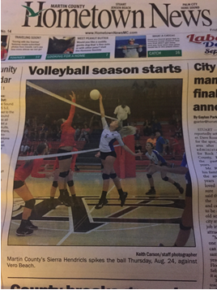
NOTES OF APPRECIATION
Breakfast from Hendricks and Deslis families last couple of weeks and especially the Sherman family for sponsoring this morning’s “Welcome Back” breakfast! Thanks also to the Gilliam family for their donation of colored paper.

