**General News and Info**

**Thanks to the Mason family** for sponsoring this week’s staff breakfast and to the **Millard family** for the delicious homemade (still hot from the oven!) breakfast breads! Thanks also to the **Gilliam & Rice** families for hearing our plea for soft tissues and an **anonymous donor** of soft tissues and umbrellas!

**Poetry contest** (attached)

Chastain **welcome back event** (attached)

Friday is the last day to purchase your 2017-18 Ed Foundation of MC-sponsored **Coupons for Classrooms books** – benefiting Interact and Debate. $25 with $6 profit for Clark per book. Stop by the front office to buy yours ASAP!

The Clark **College Fair** is Thursday, Oct. 5 in the Knowledge Room from 9-11 am and at PSL Civic Center in the evening (many more schools). See emails from Ms. Jones with full details.

**PSAT registration for Juniors** continues. Bring your $16 to Ms. Jones ASAP to claim your space!

**Free November SAT Registration for Hurricane Irma-Impacted Students**: To support students and families affected by Hurricane Irma, the College Board will offer a free November SAT registration. The free November SAT registration is for students who are experiencing hardship and/or displacement due to the hurricane and are in an area designated by FEMA (Martin County is one of those areas). Students who are registered for the November SAT should call Customer Service to receive a refund of their registration and late fee. Students can register and contact Customer Service through October 25. To reach Customer Service, please call 866-756-7346.

Your students have the opportunity to explore careers that match their skills and interests through the **ASVAB Career Exploration Program** this semester as part of Career Development Month.  We will administer the ASVAB assessments on Friday, November 3rd, from 8:00 a.m. – 11:00 a.m. and an interpretation of their results will be provided on Thursday, November 30th, at 11:00 a.m.  Both of these meetings will take place in the Knowledge Room at Clark.  Registration is required.  Contact Dr. Bonds before Friday, October 27th.

**Great Explorations 2017: “Where Dreams are Discovered”** is a career exploration event hosted on the IRSC Main Campus on Friday, November 17th.  More than 1,000 high school studentsfrom the four-county area will participate in hands-on activities designed to help them gain an understanding of the connection between their career interests and their educational road to success. Required registration process includes submitting a signed permission form and completing an online survey.  Contact Dr. Bonds as soon as possible.  The registration process must be complete by Wednesday, October 11th.

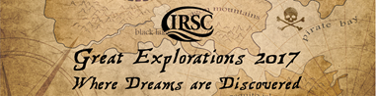

**Need volunteer hours?** Check out the many local agencies who would love to have responsible students: https://sites.google.com/sbmc.org/student-community-service/opportunities?authuser=0

**Good News!**

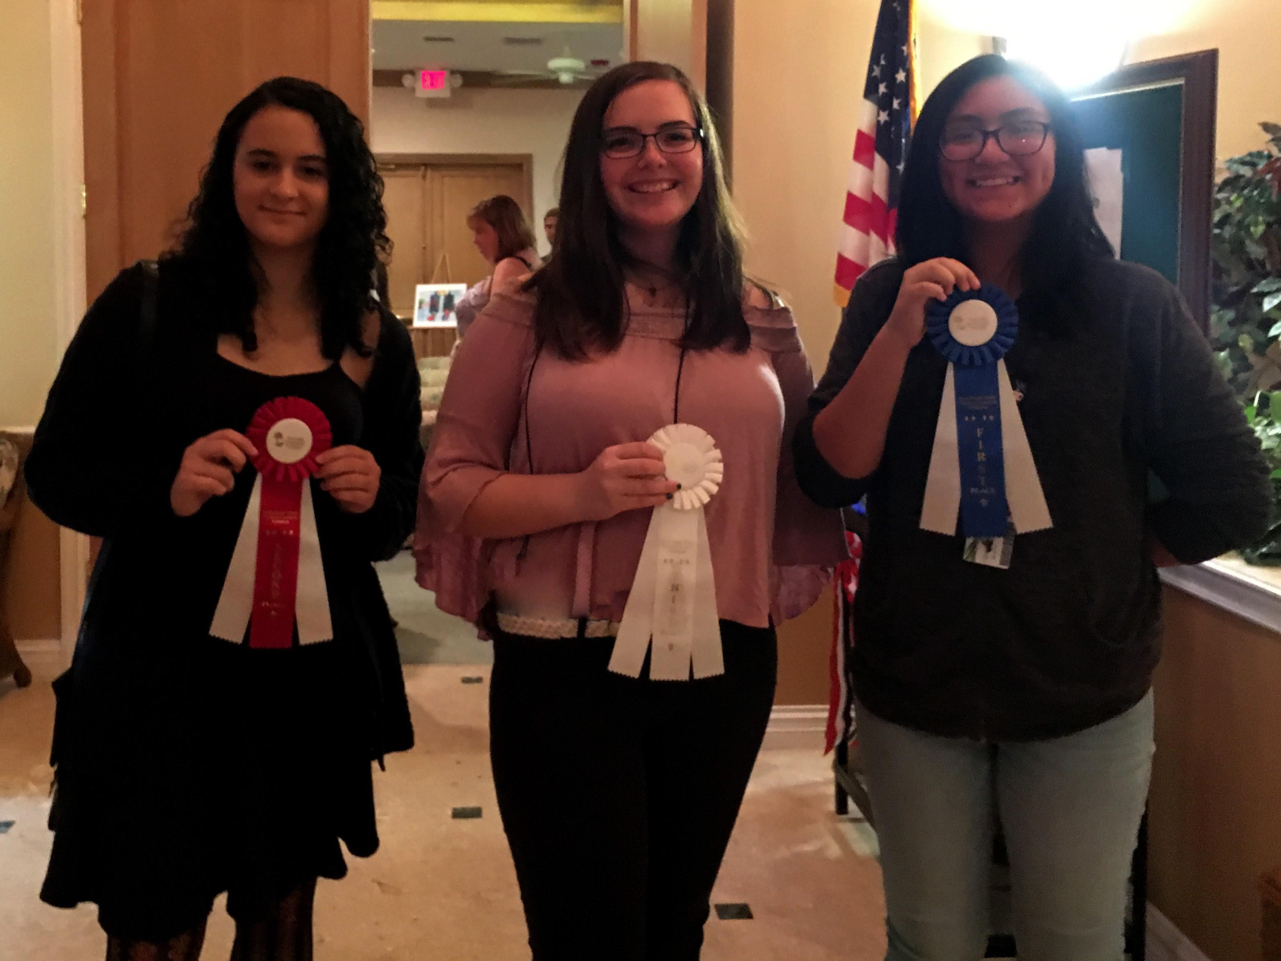

Congratulations to students from Mrs. Gribble’s Portfolio Art class for their amazing participation in the Never Forget 9-11 Tribute Youth Art Exhibition and Contest presented by Forest Hills Community Outreach. All artwork was displayed on Thursday Night in Palm City. The following Clark students won awards in various categories from among the 128 county-wide submissions:

**Crystal Aguilar – 1st place, Ana Paes– 2nd place, Theresa Legein--3rd place, Faith Olsen – 3rd place, Daisy Brant – Honorable Mention**

Congratulations and thank you for showing your remembrance of this historical tragedy that we should never forget.

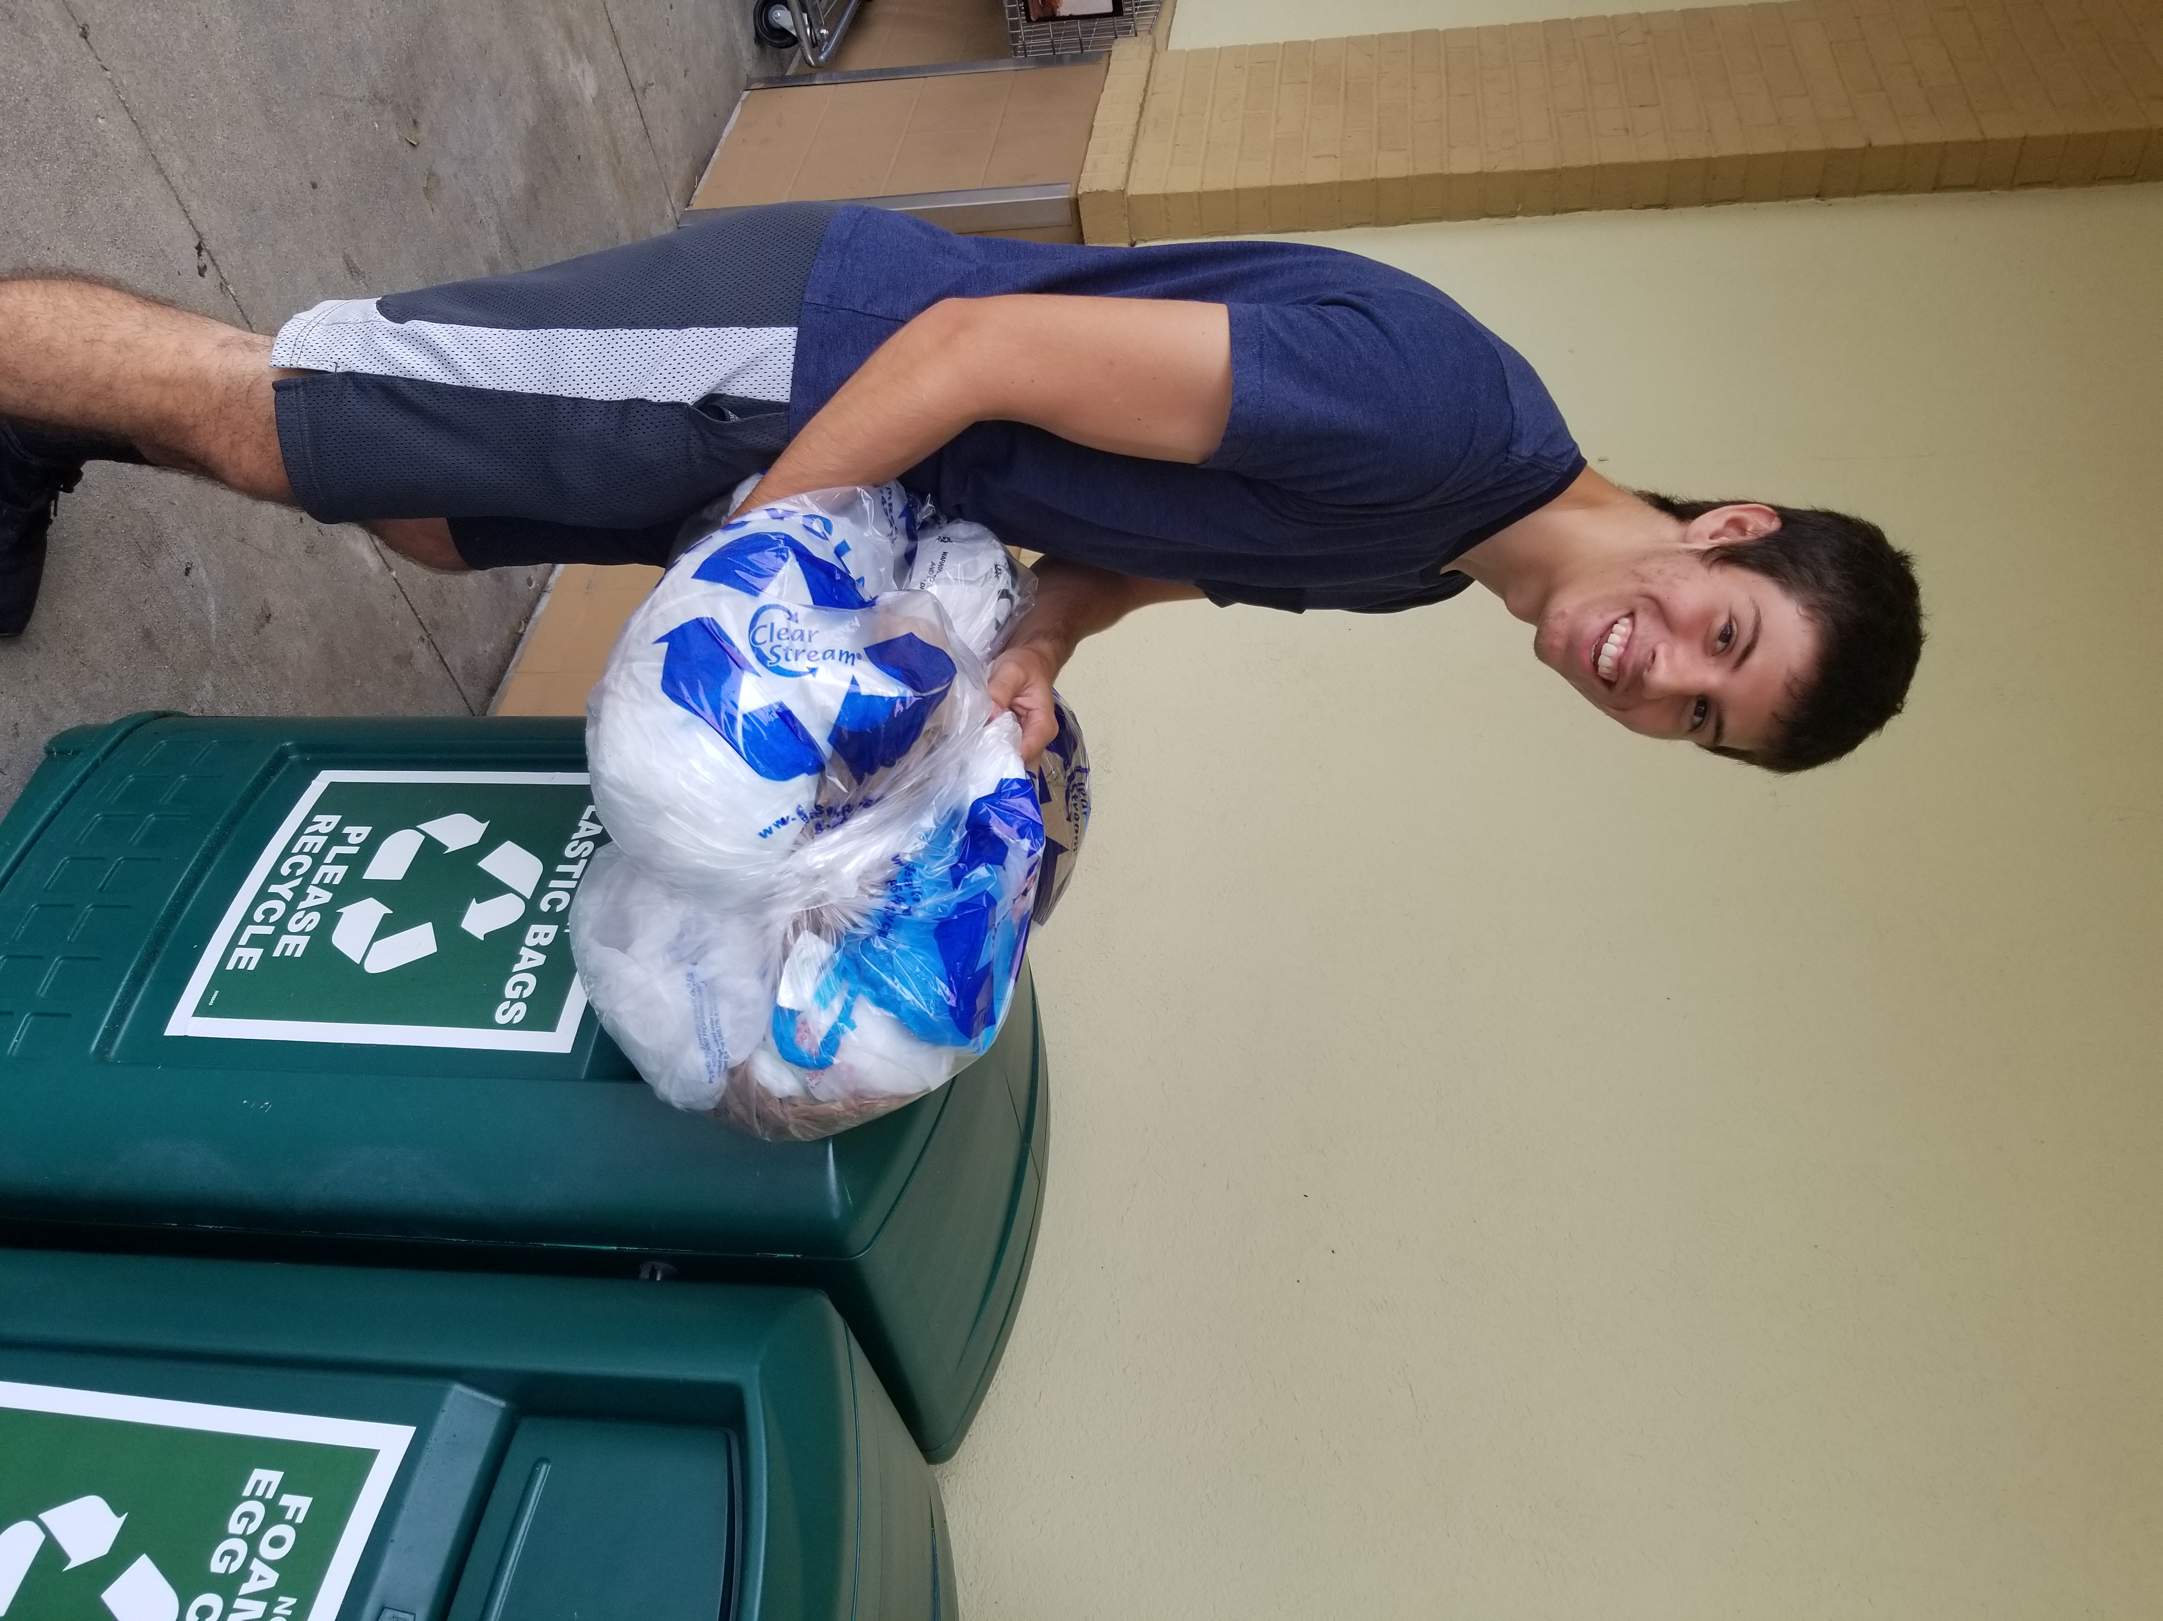

Thanks to Clark student, **Robert Devaney**, for transporting the first load of plastic bags to be recycled to Publix as part of a district wide iniative!

Congrats to a couple of the Clark swimmers and divers!

1-meter diving: 3rd place **John Klein** (SF) versus MC

**Logan Woodcock** (MC) versus SF: 2nd in IM Relay, 3rd in 400 Free Relay, 3rd in 500 Free

And versus Westwood and Pine School Logan placed 2nd in the 200 IM

<http://www.tcpalm.com/story/sports/high-school/2017/09/26/martin-county-swimmers-sweep-south-fork/702671001/>

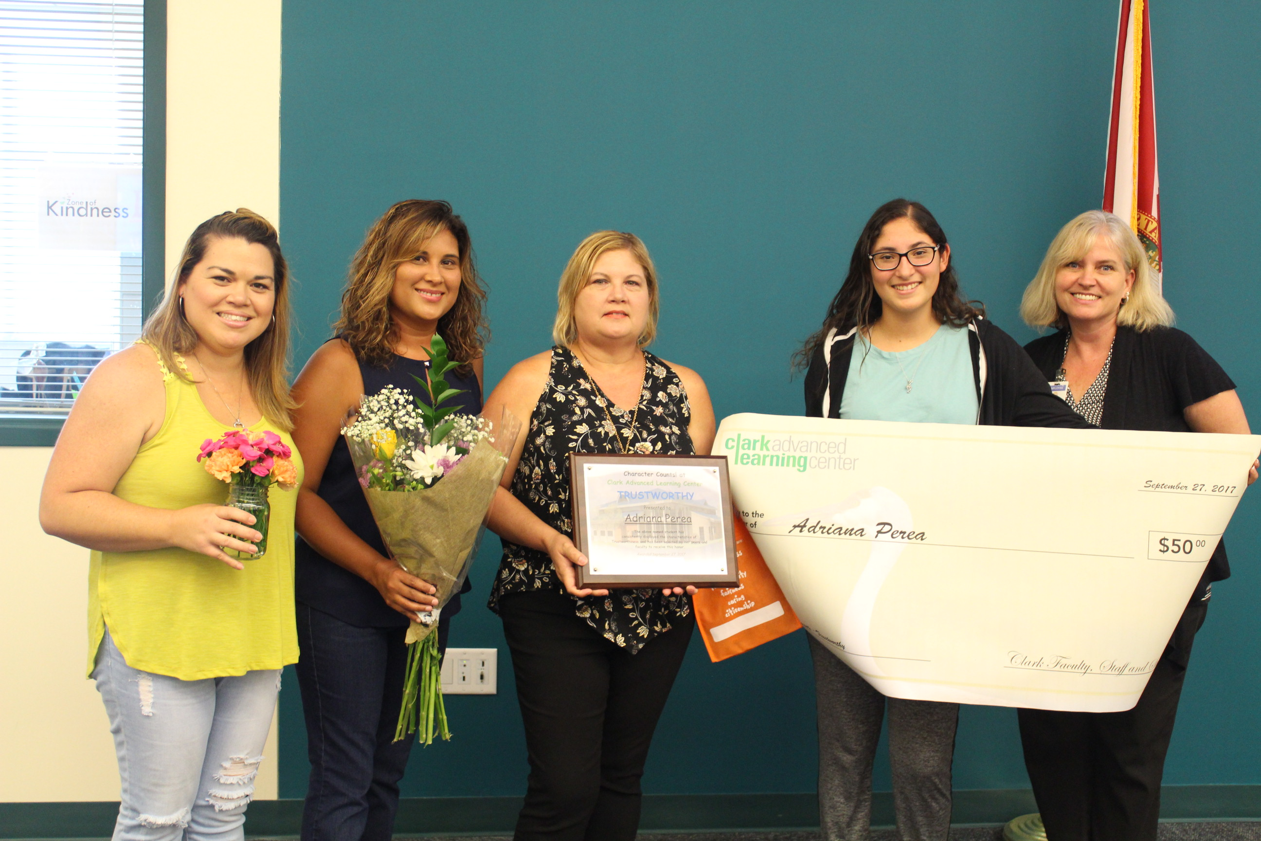

**Adriana Perea** was the student selected as the Clark Character Counts! October Pillar of Trustworthiness Student of the Month. She was surprised at an assembly on Wednesday by her family and some great swag! November’s pillar is Respect.

At that assembly, we were also honored to have Judge Kathy Roberts discuss the Bill of Rights as part of a recognition of Constitution Week 2017. The kids are still talking about all they learned!