Supporting Martin County Students
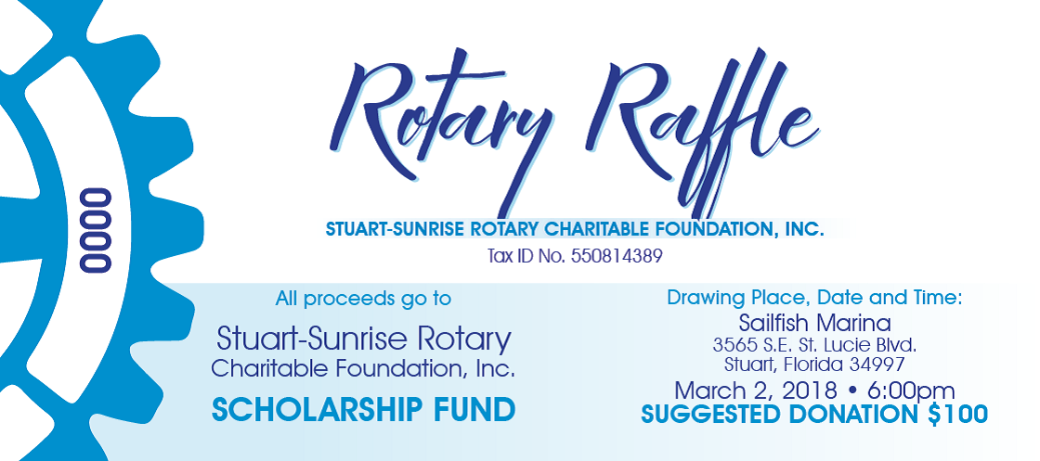
$25 each or five for $100
Major Prizes
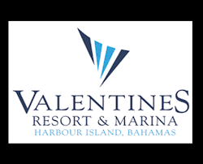
Weekend stay at Valentine's Resort and Marina, Harbour Island, Bahamas with airfare for 2
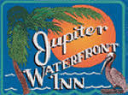
Jupiter Waterfront Inn hotel stay
Marriott Hutchinson Island 3 day/2 night stay

4th Annual Rotary Raffle
Prize packages include
Island Stays, A B&B visit, Restaurants and sailing, golf, kayak rentals, and museum tours are all part of the 3 prize packages that will be awarded!
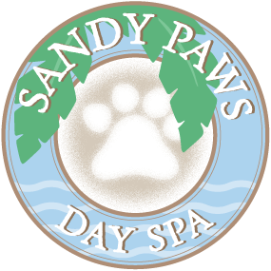
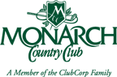
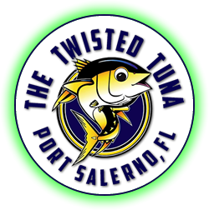

Tickets are $25 each or 5 for $100
Proceeds fund College Scholarships for Martin County Students
Like us on Facebook
www.stuartsunriserotary.org

Drawing is Friday evening, March 2 at Sailfish Marina , 3565 SE St. Lucie Blvd in Stuart.

