**Announcements**

Yes, Clark and IRSC have classes on Monday! No, we do not have a bus or lunch from MCSD, but you can buy pizza lunch. Sign up in the front office BEFORE 9:30 am.

SAT prep course being offered (see attached)

The Chastain Campus is looking for student artwork to display on their art gallery wall. See Ms. Judd if you are interested.

Last call for the Clark Annual Parent and Student Surveys.  We value your feedback and really need to hear from more students. Email [ljudd@irsc.edu](mailto:ljudd@irsc.edu) if you can’t find the link for your grade level.

Thanks to the families who attended PAP last night and learned a lot about financial aid and more. IRSC is hosting additional financial aid sessions from 6-7p in the enrollment center in the A building on the following dates: 3/6/18, 4/3/18, 5/1/18

Renaissance Festival was again a hit! Thanks, Mr. Judd for organizing this! 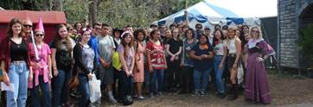

**Recognition**

Special thanks to our Black History Month guest speaker, Kherri Anderson.  Ms. Anderson is the Deputy of Elections Outreach for the Martin County Supervisor of Elections and is a Certified Elections/Registration Administrator. Ms. Anderson, is a native of Martin County and graduate of Florida Atlantic University. She offered wonderful words to our student body at our monthly assembly this week.

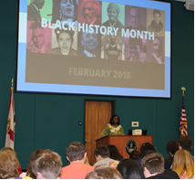

At the same assembly, we were able to celebrate the February Caring pillar recipient, Claire Arcement. Claire was nominated by several peers and staff for being such a pleasure to be around and brightening everyone’s days. Her family came to join her for this surprise honor!

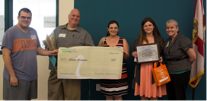

We also celebrated the winners of the first ever River Writers’ Creative Writing Contest hosted by Mr. Escandon.

In the comic strip category: 1st place: Micaela Pedro, 2nd: Faith Olsen, and 3rd: Crystal Aguilar

In essay: 1st: Jacinda Kingsbury, 2nd: Gemma Neese, and 3rd: Susannah Cleary

In Short Story: 1st: Gianna Califano, 2nd, Bianca Grosso, and 3rd Anthony Giannotti

Finalists’ essays, short stories, and comic strips will be published the first week of March in the Winding River Online Literary Magazine [www.windingriverwriters.com](http://www.windingriverwriters.com). For more information about River Writers’ Club, contact us at [windingriver@clarkalc.net](mailto:windingriver@clarkalc.net) or stop by to see Mr. Escandon in Room 132.

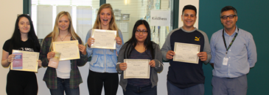

**Club News**

Interact Club’s Change-for-Change collection last week was super in providing $60.10 for House of Hope. Thanks to all who contributed change as well as money that did not jingle! House of Hope is a nonprofit agency that provides food, clothing, furniture, financial assistance, information & referral, and life-changing case management services to Martin County residents in need. <http://hohmartin.org/>

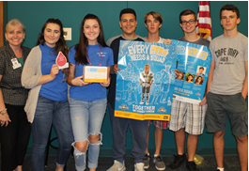

Please come out to One Billion Rising for Justice Martin County 2018 this Sunday at 3:00 pm at Gazebo Park in Stuart and stop by the UNICEF Club table. Learn more about what we do and enter to win some raffle prizes while raising funds for UNICEF USA.

Fundraiser for Leukemia and Lymphoma Society sponsored by Clark’s Interact Club from Monday, February 19 through Thursday, March 8. Collection boxes will be in every classroom for the three weeks for donations. Blood drops will also be for sale for $1 each to be posted – bag of cotton candy in exchange for the donation to claim, name, and hang a blood drop! Video link:  Student Series Video   -- Sam is out hero who needs many contributing heroes to feel better – and for scientists to find cures!!!!! Clark’s online page for contributions- <http://events.lls.org/pages/pb/Clark-Advanced-Learning-Center-2018>

**Appreciation**

Thanks to the Rice family for a super delicious staff breakfast this week!

Last night was the MCSD Volunteer of the Year celebration for the recipients from the 2016-17 school year.  We were pleased to honor co-parent volunteers, Katie Carroll and Kathy Peterson, student volunteer, Jimmy Peterson, and business partner, Martin Health Systems.

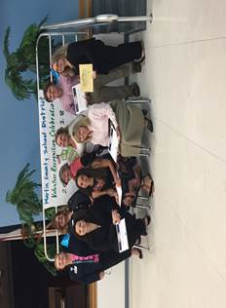

**Leslie Judd, LMHC, Ed.S.**

Assistant Director

Clark Advanced Learning Center

772.419.5758

**At Clark, we Fully Believe In student success!**

